Lessons from an American Weapons Designer
Chapter from ‘Battlespace of Mind’ by Michael McCarron (Galway, Ireland)
Working rough draft, last modified 6/2/19

From before Sun Szu, encompassing the famous Admiral Gorshkov, and extending well beyond future INFO-CYBER warriors, the dictum: Control the Electromagnetic Spectrum and Victory is Promised as your Reward - will be the mandate for success and survival in the coming dawn of the Age of Automated Reasoning, the advent of Synthetic, Sentient Species
- John Norseen 2000

Dr. John Norseen was an American weapons designer working on what today would be referred to as a Neuroweapons, he was also a lecturer at George Washington University in DC. When he was employed by Lockheed-Martin[9] in the 1990s and early 2000s, the concept of neuroweapon was not widely known outside the deepest of black operation funded military and defense sectors. Even, today, the development of such weapons is a highly classified and compartmentalized affair. Luckily, John Norseen was a bit more candid and conversational then most weapons designers working in classified positions for defense contractors. Late in his career, for a brief time he held conversations with the artist Duncan Laurie who worked in a field of radionic art [see more on radionics from German Neuroweapons section].
Norseen and Laurie’s correspondences were published by Laurie on the internet after Norseen died from a heart attack at age 53. He also has left behind two papers still remaining on the internet. Attempts at finding journal articles and publications from his time as a Navy officer at the Naval War College have come up empty, for instance the Naval War College has no record of his attendance, although it is confirmable he did attend, and was an officer in the US Navy working at one point in Intelligence. His thesis at the War College was on applying Neuroscience research to anti-terrorism investigations[2]. So we are fortunate that he leaked certain points about his work in his conversations with Duncan Laurie and left behind some unclassified research papers published by a small computer engineering association, ‘American Computer Scientists Association’ [1]
The first article I could find on the work of John Norseen dates to a Newsweek article from 2001 he was interviewed for under the title, ‘Reading your mind and injecting smart thoughts’[2] In which he talks of being able to read terrorist suspects thoughts remotely. In a subsequent article from 2001 in the Washington Times ‘NASA plans to read terrorist’s minds at airports’, Norseen notes:

“Space technology would be adapted to receive and analyze brain-wave and heartbeat patterns, then feed that data into computerized programs ‘to detect passengers who potentially might pose a threat,’ according to briefing documents obtained by the Washington Times. NASA wants to use ‘noninvasive neuro-electric sensors,’ imbedded in gates, to collect tiny electric signals that all brains and hearts transmit. Computers would apply statistical algorithms to correlate physiological patterns with computerized data on travel routines, criminal background and credit information from ‘hundreds to thousands of data sources,’ Nasa documents say” [3]

While it appears the bulk of his work was done at Lockheed-Martin he also had other projects such as working on a team for whole brain emulation in a cybersecurity context with Alert Grid Alliance, Inc. working on a product known as ‘CYPHER’ a quantum intelligence cyber security system, which is claimed to have begun with Sanders Associates [see infobox, ‘Sanders Gaming’], who also did early work in video game consoles, later shipped under Magnovox branding, as well as the the Electro-Optics Lab at NOSC in San Diego under the auspices of the Naval Sea Systems Command [4]. Although interesting the main research area to focus on for this research is that related directly to ‘Semiotics’ or what John Norseen termed in his conversations with Duncan Laurie, the ‘Norseen Semiotic’.

Semiotics

Norseen’s innovation in the field of neuroweapons was termed by him ‘BioFusion’ First, published in academic articles at SPIE in 1999. He gives an account to Duncan Laurie below:

BioFusion is my name for the next generation of biometric security/intelligent inter-netted security systems. Please note that a fundamental basis to BioFusion is that brain structures execute biological functions, and that such functions can be represented and understood as mathematical equations [Kryolov space] existing in biophysical time/space/frequency/phase/quantum state Space, spoken of here as Gabor function (wavelet/codelet) in Hilbert Space [vector space with a complete metric].
What Exactly is BioFusion?
BioFusion is described as what happens when you think (a precise mathematical operation), to include:
- When multiple sensors can detect and measure what you think, (Hyperspectral Analysis, [i.e. QEEG see Kropotov below]) and Map where thoughts are in your brain, and then via "Information Injection"
- Monitor, Enhance, Modify, Replace, or Prevent Neural Circuit Function — In Essence,
- Enhance, Replace, or Prevent THOUGHTS! Extremely Inter/Multi-Disciplinary *NSF NBIC Model*
Accordingly, such mathematical representations lend themselves to machine/computational interpretation and cross machine/computational communications, hence the capability for Human-Machine interaction, and prediction of calculated results. Therefore, if known neurological circuits, reading this page, or silently saying a sequence of numbers, or closing one's eyes and imagining a picture…let's say the image of the Mona Lisa…then with the proper sensing techniques, a display based on the underlying mathematical-biophysical space [Krylov space] can be generated which represents the very same neurological functioning. There is vast biomedical evidence of this in PET, MEG, EEG, FMRI, etc. which capture various neurological events faithfully and repeatedly. BioFusion extends the singular look of these various medical diagnostic techniques and merges them into a much more robust hyper spectral analysis across the electromagnetic spectrum, within which brain function occurs, to correlate and pinpoint with more accurate detail the specific, self-similar regions of the brain engaged in mental processing of the target activity.
(Norseen , Laurie, 2002, part 3)

Another known way of capturing electric signals in the brain, was proposed by Malech using standard Radar in 1974, this is also the method that a former MI-6 agent turned whistleblower, Carl Clark,[28] noted was used for covert applications of this technology [see neuroweapons section]. Here is an outline of how a Brain Emulation application works. Taking in biometric data and then applying statistical learning algorithms to that data and formulating a profile and Brain map of the observed target.

In a more technical definition given at a conference in Russia on the topic of ‘Reflexive Control’ [see discussion of Reflexive Control below]. Norseen writes:

BioFusion is the increasing complexity of one part of the brain to share, mathematically, its information with other parts of the brain in a common, emergent family of mathematical operations, to which the inverse function, the ability to recreate or trigger stored information by using the inverse mathematics is allowable. Panum’s fusion space, horopter operations, dreams, and the distinct linkage of either end of the invariant versus holistic storage continuum of object recognition in the posterior inferior temporal gyri (ITG) as opposed to the more pure prosopopoeia [visual perception] in the fusiform gyrus (FG) are very nice examples of BioFusion in the visual perception modality. The ability to blend vision and verbal modalities in the Temporal Cortex, TC-22 and Broadmann’s Area 44, for example are also fine indications that BioFusion is taking place in more and more complex, adaptive regions of the brain. (Norseen, 2000)

BioFusion is a play on another engineering term ‘Sensor Fusion’, but usually reserved for purely mechanical sensors such as on ships or aircraft. In essence, what BioFusion is is the discretization or quantization of your thoughts into a string represented as a vector in Krylov sub-space. Alexei Krylov, was a Russian mathematician that created a special mathematics for various calculations. With the quantization of neural information it allows for a computer to process this information and do either deep mining of neural data, such as memories or insert a new string to be fed into a radar or microwave generator to generate the necessary frequencies to alter brain function and wiring. Norseen writes:

“Anyways, I was working with the Russian Academy of Science Group in Reflexive Control and we were developing an N-Dimensional Graph, called Krylov Space after the Russian bio-mathematician, Krylov, and we developed this cursory folding map of how the brain can twist and turn Semiotics into Biological Pressures, and in certain regions of the Map, the person would as one would expect under harsh and continuing intense pressures...be pushed and molded into some perverse forms of behavior. In other areas of the Krylov Map, where things were going good the Map was like a quiet estuary or shallow sea…very mellow. ….in a KRYLOV SPACE, a matrix dimensional grid of ONE IDENTITY communicating, sharing complete semiotics, with another IDENTITY…” (Norseen, Laurie, 2002, part 12)

Norseen has a specific term for each thought in his ideals of BioFusion. A thought is a ‘semiotic’, he writes:

“Well, equally, if you are aware that a person is entering an Alpha State, or better yet, a hypnogogic (falling asleep) or a hypnopompic state (pre-waking state) of an modified Theta-Alpha brain engagement region [see neurweapons section on Hypnosis]...you can actually see the subconscious mind at work and interact with it...you can actually Inject Semiotics into the mental region and see the Brain Thoughts surround the Semiotic, infuse it, and then act upon it right into the Awake States. In this way, you can DIE INJECT, action potentials...for influencing someone during the day...or you can do the same thing and get Alert Semiotics injected into the sleeping and even into the LIFE-Death interface of the Delta state...you can probe the deepest depths of the person and see just exactly how deep into the abyss, the db, you can go...You can even affect someone with Semiotic cues down at negative (-) 200 db…down at the very bottom of our semiotic ability to understand information, and right at the zone where Alfven Wave corridors of the brain Magnetite exchange ZPE [zero point energy] in the dendritic neuropil at nanoscale, discrete bandwidth, channels. It is right here in the Marianas Trench of human thought/perception, that the person is exposed to the Universals of Quantum State potentials, and that each individual thought or Semiotic Identity is formed, only to then bubble or shoot right up to the surface of positive thought realms.
Just as you can look into an aquarium or a fish bowl and see the stuff at the bottom work its way up to the surface, you can track the origin of Semiotics from Alfven Wave Interactions with ZPE, from the plumbed depths of the Brain.
This is really pretty cool stuff, because it allows us the opportunity to use Radionics to condition or reinforce or direct the destination of the most basic to the most sublime of human thoughts and the HUMAN CONDITION.” (Norseen, Laurie, 2002, part.6)

Semiotics is a field of inquiry usually in reference to Linguistics, it typically connotes a sense of meaning to a linguistic object.

Semiotics is a discipline (or an attempt to create a science) of combining the theory of signs (representations), symbols (categories), and meaning extraction (see the glossary).Semiotics is an inclusive discipline which incorporates all aspects of dealing with symbols and symbolic systems starting with encoding and ending with the extraction of meaning. [23]

In the defense industry Semiotics has largely been identified with the work of C.S. Pierce, an American philosopher from a Boston Brahmin family, his wealthy pro-slavery upbringing was later given up for a semi-transcendentalist lifestyle on his farm where he lived in poverty. His affects and influence on the defense industry scientists that use his Semiotics and arguments of Logic is deep. In the appendix of Norseen and Laurie’s communications there is an explanation of Piercean Semiotics that is used by Norseen in his work, along with a scientist we shall read more deeply about, Ed Nozawa later. Semiotics being the study of signs, the definition of according to Pierce:

“Anything (R[epresentant]) which is so determined by anything else, called its Object (O), and so determines an effect upon a person, which I call its Interpretant (I).”

Which leads to the Piercean triangulation: Object-Interpretant-Representam

- Complex conceptual structure reduced to a single triadic sign
- Unique system - all others are dyadic (two-part)
Signs may be concatenated to construct concepts
Peircean system of logic developed from the sign

An important concept in Piercean Logic is the notion of triadic pathways rather than dyadic pathways, in this sense it is actually a good precursor and informant to Quantum Computational ideals regarding superposition.

Another important element in Pierce’s thought and influence on defense contractor engineering and science is that of the Hypothesis. In many of the logic flows of these weapons designers is the concept of forming a hypothesis then referencing a knowledge base then re-running whatever iteration of the task is involved in. As we shall read later under Nozawa the concept of ‘closed loop’ systems is a prevalent dynamic in such systems engineered under Piercean logic. Creating a truly cybernetic system where all decisions potentially could be automated and based on computer algorithms with no human intervention.

In the terminology of Norseen, then the individual whether in a read or write operation to their brains, is the Interpretant, where the object is qualified by an Representatum. So that we understand that a sign can be manipulated by the systems under design and spoken of by Norseen, as well it can be used to simply read signs from a human brain.

Norseen referred to the process of manipulating the Semiotic or signs as ‘Thought Injection’ which is given in a section narrated by Duncan Laurie in their correspondences:

Theoretically, according to Norseen, each thought represents an energy dispersion pattern which can be monitored by mixed electromagnetic sensors and described mathematically as a “Brain Print”. This brain-print can be inverted and retransmitted back into the brain much like an encoded memory. Subsequently, the brain will act upon this inverse signal as if it were a real signal from the environment.
Norseen's point was that if you could trigger that part of the brain remotely, via a transmission of some kind, the receiver would be all but powerless over the transmitted response. [a manchurian candidate with no self-will or control depending on variables such as genes and biochemistry, see neuroweapons section manchurians]
The implication was clearly that a command (encrypted as information contained within information), akin to a hypnotic suggestion, can be buried within unrelated visual and auditory information, to be broadcast to the general public. Norseen strongly suggested these techniques were connected to the Columbine murders, as though the killers had been infected from encrypted web sites beforehand, designed intentionally as trial behavior test scenarios.
[ see AI section, Intelligence infiltrates gaming communities] (Norseen, Laurie, 2002, part. 1)
Although hypnosis is mentioned here see below for a discussion of use of Hypnosis in Thought Injection using Semiotics. The process of how this works according to Norseen is that he uses ‘BioFusion’ (sensorfusion or datafusion) to collect all the thoughts (semiotes) in one’s head then has the ability to either do deep data mining and profiling to either extract or insert more information, resulting in either a cracked mind or a rewired mind.

He goes further into how this works in an interview with SIGNAL Magazine, a military journal:

Now that bio-fusion research has developed beyond the initial stages and the database of what, how and where thoughts occur in the brain is mature, scientists are looking at information injection, a contentious issue, Norseen admits. The concept is based on the fact that human perception consists of certain invariant electromagnetic and biochemical lock-and-key interactions with the brain that can be identified, measured and altered by mathematical operations. If researchers can re-create the inverse function of what has been observed, they gain the ability to communicate or transmit that information back--intact or rearranged--to the individual or someone else, Norseen says. "When you get down to the mathematical properties, information injection is beginning to be demonstrated."
The brain is very susceptible to accepting information that is either real and comes from its own memory mechanisms or from injection from an outside source, Norseen notes. "I am sure you have memories of when the lawn was being cut in late summer and of the smell of the chlorophyll," he says. "The chlorophyll would then evoke other memories. I could possibly ping you with a light sequence or with an ELF [extremely low field] radiation sequence that will cause you to think of other things, but they may be in the area that I am encouraging. Those are direct ways in which I can cause the inverse function of something to be fired off in the brain so that you are thinking about it. I have now caused you to think about something you would not have otherwise thought about."
By using information injection, a person could be isolated from a group and made to believe that something is happening, while others in the group are being left alone. Likewise, someone at a command post monitoring information on a screen could be affected. Some experts believe that adversaries now are designing techniques that could affect the brain and alter the human body's ability to process stimuli. (Berry, 2000)

As can be seen, this technology has a very brazen double edge. Of course it could be used to monitor a criminal to prevent them from committing crime, probably in the context of previous conviction under the law, but it could also be used by criminals of another sort to easily manipulate and control innocent persons, thus being an even greater threat to security then it could potentially prevent. What we are talking about here is the modification and alteration of behaviors. The modification of behaviour is understood by Norseen as Reflexive Control, which was pioneered by not just Soviet scientists and Nazi scientists but also has it’s fair representation in American psychological scientific literature. For instance several members of the editorial board of a publication dedicated to Reflexive Control in Russia come from the United States and Canada.

One Russian researcher now working for the United States government, also directly influenced by the Piercean Semiotics paradigm is Alexi Sharov. He merged logical semiotics with biology, to work in an area known as Biosemiotics:
Biosemiotics and cybernetics are closely related, yet they are separated by the boundary between life and non-life: biosemiotics is focused on living organisms, whereas cybernetics is applied mostly to non-living artificial devices. However, both classes of systems are agents that perform functions necessary for reaching their goals. I propose to shift the focus of biosemiotics from living organisms to agents in general, which all belong to a pragmasphere [Pierce’s Pragmatic Philosophy] or functional universe. Agents should be considered in the context of their hierarchy and origin because their semiosis can be inherited or induced by higher-level agents. To preserve and disseminate their functions, agents use functional information - a set of signs that encode and control their functions. It includes stable memory signs, transient messengers, and natural signs. The origin and evolution of functional information is discussed in terms of transitions between vegetative, animal, and social levels of semiosis, defined by Kull. Vegetative semiosis differs substantially from higher levels of semiosis, because signs are recognized and interpreted via direct code-based matching and are not associated with ideal representations of objects. Thus, I consider a separate classification of signs at the vegetative level that includes proto-icons, proto-indexes, and proto-symbols. Animal and social semiosis are based on classification, and modeling of objects, which represent the knowledge of agents about their body (Innenwelt) and environment (Umwelt). (Sharov, 2010)

Reflexive control is defined as a means of conveying to a partner or an opponent specially prepared information to incline him, her, they to voluntarily make the predetermined decision desired by the initiator of the action. It is an interesting point that the usual understanding of reflexive control is usually a ‘voluntarily’ made, but with thought injection we are talking about a reflexive control that is involuntary even unconscious. Defense researchers from the European Union give the following technical definition of Reflexive Control:

According to Russian methodologies, the theory of Reflexive Control (RC) allows an initiator to induce an adversary to take a decision advantageous to the initiator through information manipulation. The RC theory encompasses a methodology where specifically prepared information is conveyed to an adversary, which would lead that adversary to make a decision desired by the initiator. The methodology is generally understood by Russian planners to be applicable in a wide variety of situations, and is deeply rooted within Russian Information Warfare concepts. Because theory envelops the Russian understanding of information as both technical data and cognitive content, ‘information resources’ are understood as technological as well as human. In principle, a well-developed (global) cyberspace presents theorists and operators of RC and RC methodology with numerous possibilities to affect their adversaries. This paper explores ways in which RC can be exercised with the help of the cyberspace. [24]

Norseen worked directly with one prominent Russian specialist and leader of Reflexive Control, Andrej V. Brushlinsky, who according to Laurie remarking on Norseen’s perceptions of Dr. Brushlinsky:

...I was to discover, a central figure in the field of Reflexive Control was the Russian scientist and distinguished member of the Russian Academy of Sciences, Andrej V. Brushlinsky. Norseen had visited him not so very long before we met. Subsequently, Brushlinsky was found robbed and murdered. Norseen believes he was killed by foreign agents, seeking the scientific protocols he had developed for a type of weaponized “thought insertion” called steganography, or “Stego Bullets” for short.
(Norseen, Laurie, 2002, part 1)

Of course one can see the direct application of thought injection whether based on the methods of Norseen or Brushlinsky, in a weaponized space, especially in warfare. So it is not surprising that there would come some espionage intrigue along with this research area. So it is important to understand what precisely is happening in Reflexive Control that it would be such a high value target in international espionage.

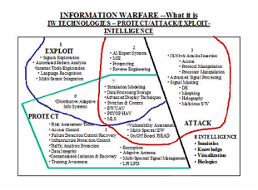
Slide from Norseen Presentation (Norseen, Laurie, 2002, part 1)

So traversing from Reflexive Control engineered through Thought Injection we come to larger issues that affect groups, collectives, and societies as a whole. As the ‘Russian’ meddling in the US 2016 election clamor has brought to the attention such concepts of Information Operations by hostile forces to the attention of the average citizen, it should be mentioned again that in 2011 British GCHQ sponsored studies on undermining social network perceptions on a mass scale. Yet, there is not much meaningful discussions of these terms. Information operations and warfare, also known as influence operations, includes the collection of tactical information about an adversary as well as the dissemination of propaganda in pursuit of a competitive advantage over an opponent.[6]. Information Operations are used in direct correlation to the methods of Perception Management. Perception Management is:

Perception management involves all actions that convey and/or deny selected information and indicators to foreign audiences to influence their emotions, motives and objective reasoning; and to intelligence systems and leaders at all levels to influence official estimates, ultimately resulting in foreign behaviors and official actions favorable to the originators objectives. In various ways, perception management combines truth projection, operations security [OPSEC] cover and deception, and psychological operations [PSYOP]. [7]

So it is not unsurprising that Norseen notes the role of his research and it’s connection to Information Operations and Perception Management in an interview with Ryan Moore, who writes for a Military careers website, Norseen expounds on this subject[8]:

“The key word in understanding Perception Management, whether for selling beer or conducting PSYOP is ‘Expectation’. Tons of advertising research dollars swirls down the drain getting commercials right and the audience wrong… You have to either match up the right situations or control the expectation level of the target audience – this holds true for either media or PSYOP management.
“But imagine if you could actually monitor expectations non-invasively, quietly, garnering sufficient measurement of how ‘Designed Information’ is interacting with the central nervous system of the intended audience. This is what the Science Of Semiotics – signs and symbols – is heading towards, and can be seen today in forms such as ‘Engagement Indices’ and other biometric techniques of audience attention. This would appear to be the logical extension of Neuro-control into marketing and perception management.
Ryan Moore asks: “What do you see as the potential civilian and military applications of ‘Information Injection’ technology?”
Norseen replies: “If ‘Information Injection’ pans out – the concept that human perception is made up of certain invariant electromagnetic, and biochemical, lock and key interactions [QSK] with brain structure which can be identified, measured and altered by mathematical/technical operations – then the stage is set to observe, capture, rearrange and play-back human mental functions from one person to another, or into any combination of man-machine system interface. The development of such Cortical Emulation Software, if successful, will rapidly usher in the potential for automated personal diaries -- Emotional Recordings, Mental Cameras, and Digital Biographies. Just as we today catalogue millions of people by fingerprints, this strongly suggests the future ability to use Brain-Prints as the key biometric signature identifier in Total Information Awareness.[5]”
(Norseen, Laurie 2002 Part 1 ‘Reflexive Control’)

Norseen goes even further with this technique suggesting it’s automation and usage by computer systems in an academic paper:

The concept of injection of information for Information Operations from one human into another human, or from a machine generation of information into a human, the inverse function is utmost and vital. In order to trigger, or refine, or replace, or sharpen an old perception in the human, or to create brand new perceptions, the exact inverse function must be known, or very close to it, in order to fool the brain into accepting it as real. And this inverse injection must also very closely model the exact E and H fields, the electromagnetic field shapes that the original Gabor-like Function in Hilbert Space occupied. (Norseen, 2000)

As can be seen as a weapons designer there is no cloudiness to the intent behind the weapons systems he was designing. In the field of Information Operations in warfare and specifically creating a genre of Neuroweapons capable of such abilities as direct thought injection the ability to undermine an enemy in a battlespace is of unimpeachable value.

Thought Injected Reflexive Control

At this point it is a worthwhile endeavor to trace the development of this technology, specifically focusing on Semiotics and it’s role in Reflexive Control, other areas of Neuroweapons history and development has been covered in the preceding chapter on ‘Neuroweapons’.

A brief history of Russian Reflexive control research is related:

The Soviet and Russian Armed Forces have long studied the use of reflexive control theory, particularly at the tactical and operational levels, both for maskirovka (deception) and disinformation purposes and, potentially, to control the enemy’s decision-making processes. For example, the Russian Army had a military maskirovka school as early as 1904 that was later disbanded in 1929. This school, the Higher School of Maskirovka, provided the bases for maskirovka concepts and created manuals for future generations.
Since the early 1960s, there have been many Russian intellectual “giants” who have emerged in the field of reflexive theory. In the civilian sector, these include G. P. Schedrovitsky, V. E. Lepsky, V. A. Lefebvre (who now lives in the West), D. A. Pospelov, V. N. Burkov, and many others. The foremost theorists in the military sector include V. V. Druzhinin, M. D. Ionov, D. S. Kontorov, S. Leonenko, and several others.[11]

As one reads scientific publications on Reflexive Control and Semiotics a name that is often encountered is that of V. A. Lefebvre and D.A. Pospelov. Lefebvre, now teaching in the United States, has created an interesting paradigm known as Reflexive Game Theory, see Senglaub below for Semiotic Cybernetics examples. A researcher, Sergey Tarasenko, notes:

The Reflexive Game Theory (RGT) has been entirely developed by Lefebvre and is based on the principles of anti-selfishness or egoism forbiddenness and human reflexion processes . Therefore RGT is based on the human-like decision-making processes. The main goal of the theory is to model behavior of individuals in the groups. It is possible to predict choices, which are likely to be made by each individual in the group, and influence each individual’s decision- making due to make this individual to make a certain choice. In particular, the RGT can be used to predict terrorists’ behavior.
In general, the RGT is a simple tool to predict behavior of individuals and influence individuals’ choices. Therefore it makes possible to control the individuals in the groups by guiding their behavior (decision-making, choices) by means of the corresponding influences.[19]

It is important to point out that the anti-Terrorism aspect is a particular application of Reflexive Game Theory, while as Lefebvre writes, in general it can be used for mass applications. It is interesting also that this scientist has sought not only to apply reflexive control to humans but also robots and has mixed them together in his studies in groups. Tarashenko notes regarding the influence of robots on humans in 2010:

However, robots are forbidden and should not physically force people, but must convince people on the mental level to refrain from doing a risky action. This method is more effective rather than a simple physical compulsion, because humans make the decisions (choices) themselves and treat these decisions as their own. Such technique is called a reflexive control.
The task of finding appropriate reflexive control is closely related with the Inverse task, when we need to find suitable influence of one subject on another one or on a group of subject on the subject of interest. Therefore, it is needed to develop the framework of how to solve the Inverse task. This is the primary goal of this study. [19]

In this sense using RGT crosses boundaries between strictly human-to-human interactions and goes into robot-to-human or AI-to-human interactions to generate desired behaviours using an AI agent.

With the collapse of the former adversary of the Soviet Union many Russian scientists that had previously been employed by the KGB and GRU found themselves in need of funding and sponsorship. Quickly stepping into this sponsorship vacuum came the American secret intelligence agencies seeking to acquire Soviet technology. Norseen it is known, worked with Russian scientists in the Reflexive Control area of expertise, notable among these is the previously mentioned murdered scientist Brushlinsky, AI pioneer Dr. Prospolev, and AI designer V.K. Finn and founder of RGT, Lefebvre.

The collaboration between Russian and American defense engineers and scientists can be traced, at least publically, to 1995. When Russian groups sought out foreign funding sources:

One of them (calling itself a Semiotic Design and Control Group of Russian Academy of Sciences) has recently communicated an interest in working with researchers in the United States. In response to this interest, US government has sponsored, and many other government agencies were involved in, two workshops: one in Columbus, Ohio in June 1995; the other in Monterey, California in August, 1995. [23]

Norseen’s use of Semiotics, Reflexive Control and Thought Injection is not new with him. In the research corridor of New Mexico largely associated with US Government scientific research, for instance Sandia Labs is located there, there was a team created at the Physical Science Laboratory at the University of New Mexico State University. This team was founded by Russian emigre Vladimir Lefebvre who is cited by Norseen in his research, the commonalities between Norseen’s research and the PSL group is obvious:

The theory allows the modeling of high-level value systems. Using the theory, values such as self-esteem, pride, human dignity and willingness to sacrifice may be incorporated into modeling of human agents. Other theories of human behavior do not allow for modeling such non-utilitarian factors. Using a model developed from Reflexive Theory, it will be possible to predict, for example, which of a group of potential terrorists might be susceptible to recruiting by terrorist organizations such as al Queda.

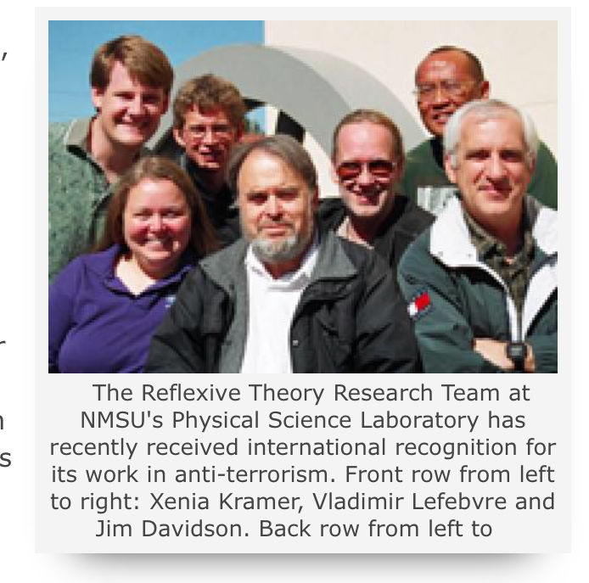
Source: http://newscenter.nmsu.edu/Articles/view/1397 (2003, accessed 5/27/19)

The team received a award for their research in Russia in 2003. While created with good intentions for security, it is also obvious that such simulations could be also used for nefarious purposes if a rogue element developed with this technology.

Norseen talks about the early development of Semiotics and Reflexive Control to Laurie:
Of Peircian Scientific Semiotics and its role in United States national security, I can honestly say that I was part of the inception in the early 1990’s and have watched over the last decade the growth from the first national security working group on scientific semiotics to where it is now a recognized science effort around the world...but with not nearly enough Book elucidation, and still lacking a dedicated National Scientific Philosophy linkage into National Security. Almost all of the pacing Soviet scholars that I have met are now dead or corrupted…and most of the working semiotics is now under a classified rubric. At least I can edify about the frolicsome years from 1995-2002 where no holds barred and semiotics as the New Occult held sway...try to search on Lycos with the terms NSA PSYOP...there is a link that you need to see…I will get it to you later. The link describes how semiotics and brain communications can be done covertly. Imagine that. [see note 29 in original, discussed in Neuroweapons Hypnosis section of this work] (Norseen, Laurie, 2002, part 15)
The ‘frolicsome years’ that Norseen talks about are reflected in a meeting with Russian researchers. Norseen talked to Laurie regarding his encounter with Russian scientists at a social event in the US, Laurie writes regarding this:

The next time he found himself at the Double Eagle [a bar in New Mexico], it was with a group of Russian semioticians with whom he was collaborating. This eclectic group was formed in the early 1960's by a Soviet General that set up a secret program of covert reflexive control operations with the KGB and GRU now under the direction of a certain Dr. Pospelov, of extreme interest to Lt. General Ken Minihan, the Director of NSA [National Security Agency] (DIRNSA). Norseen was tired when they arrived. Then, as he walked in, the lights of the saloon went crazy. The one person capable of working the entire bar, physical and non-physical, had arrived. As Norseen worked his way into trance once again, the entities allowed him to enter the minds of his Russian colleagues, probing their thoughts and memories. To their horrified surprise he began casually rattling off the contents of their mind. At the conclusion of the story, Norseen was careful to point out that every one of these Russians (save the general with the gold tooth) is now dead or incapacitated. (Norseen, Laurie, 2002, part 13)
Though it is notable that he may have been employing this technology to debrief the Russian scientists in an environment of high suggestibility using alchohol as a trance agent [see THIQ below], the important point in this recollection is the role of the NSA in sponsoring these Russian scientists and in collaboration with American weapons designers working for Lockheed-Martin.

The question of Brushlinsky’s murder is an interesting one. Brushlinsky research specifically contributed to ‘Activity Theory’, important to the field of Human-Computer Interface. (See also Victor Finn Quasi-Axiomatic Theory). While the public reasoning behind his homicide was simple burglary, it is very provocative that the US was working on the very technology he was working on but for the Russian Federation. Adding to the intrigue is the statement of a leading researcher in Russia regarding the murder and theft:

“In the meantime, the director of the institute for the psychological precautions against terrorism, Professor Viktor Fersht, released a sensational statement. He said that Brushlinsky did not fall the victim of the street robbers. The briefcase contained exclusive documents about the newest, reflexive method of searching for terrorists. The concept was developed at one of the labs of the mentioned institute, and professor Lepsky was in charge of that work.”[10]
Dr. Fersht goes on further to note that the findings of this research was to be presented to a joint NATO-Russia conference.

Norseen in his conversations with Laurie notes a sea change in the development of these ideals in research as the technology became tangible and in production. Norseen, rather unwisely, used his work email address to communicate with Laurie regarding this subject. It is not known if an internal security audit picked up on his conversations or not but around 2002, during his active conversations with civilians on this subject he writes of his security clearance and assignment changing:

I just found out that my clearances have been updated. I go in for a new Top Secret indoctrination tomorrow. Also, at work, my computer and my phone and my office were taken down. I enter over the next few weeks, a new office, a new program, and new computer phone identities. Very odd.
(Norseen, Laurie, 2002, part 15)

It was not long after that Laurie has recollected[12] that Norseen’s security clearances were revoked and he was removed from classified projects. Then not too long after that died of a heart attack at age 53 [see Neuroweapons Biological Effects section in earlier part of book].

Semiotics and Quantum Consciousness

Aside from the Reflexive Control scientists mentioned in the previous section, Norseen has cited the work of various other researchers in the field of consciousness, cybersecurity, etc. In this section I shall review some of the researchers he has cited in his work relating to Consciousness. Norseen is an adherent to the ideal of Quantum Consciousness, this is that consciousness has it’s origins in the quantum planck scale of existence, and interacts with the classical world through a molecular construct known as Microtubulin (MT) in the Brain’s neural networks. A well known proponent of this theory is the anesthetician Dr. Stuart Hameroff of the University of Arizona and the physicist Dr. Sir Roger Penrose, they term their hypothesis the ‘ORCH-OR’ theory, simply known as the Orchestrated Reduction of the quantum wave state. One early researcher in Quantum Consciousness that is sited by Norseen is Dr. Koruga of the University of Belgrade. Dr. Koruga concluded in a paper with Hameroff that:

‘...MT structures lead to the conclusion that packing of tubulin is equal to information coding. This means that microtubules possess a code [like DNA, protein synthesis is based on DNA]’ [12]

With this insight Norseen was able to come up with the ideal of quantum shift keys in consciousness:

Encoding discrimination of biologic sensory information is accomplished by quantum shift keying (QSK). QSK originates in the orchestrated reduction (OR) of quantum entanglement at specific electromagnetic resonating frequency locations in protein microtubulin in the neuropil. QSK is then communicated via oscillating and standing waves in the neurosynaptic - dendritic region. This resonating mode is either reinforced or reduced by related binding, non-binding activity in other regions of the brain. At certain frequency and energy thresholds, a combining resonance is established in brain function that binds the various oscillating brain subresonances into a cohesive, sentient pattern.
Hameroff (90's) indicates that calpain is a primary neuromolecule that softens brain protein microtubulin (MT), which after a electromagnetic resonance wave interference pattern (holonomic) is presented onto the MT, the calpain is dissipated and a structural imprint of the QSK encoded wavefront interference pattern is thus captured in biologic protein structure. Sufficient memory storage mechanisms would be available in the brain to overcome state cycle limitations, since no synapto-dendritic region physically touches any other in the human brain. This establishes myriad number of switching pathways for random, but QSK coded, information patterns to be stored, with self-similar recall features in place. Access to any part of the lissajous-like distribution pattern would allow eventual reconstruction of the invariant information stored in holonomic memory. Internal stimulation of the resonant frequency modality or the actual physical bandwidth would provide the brain with internal memory recall capability. Cognitive recall is comprised of Gabor Functions in Hilbert Space. (Norseen, 1996)

With this finding and knowledge it is not hard to imagine, as is covered under the Neuroweapons section, how one could use frequencies to insert thoughts at a quantum level. Thus utilizing the calculations of Krylov sub-space to create or extract thoughts in a human brain. Another indicator of Quantum level of consciousness is that many reports of this phenomenon investigated academically have a non-local characteristic (Persinger, 2015)(Norseen Laurie 2002), which in physics is non-local not just spatially but also temporally.

Norseen Presentation Slide

As mentioned others have found a non-local effect in neurowarfare techniques. One such technology is known as ‘transcommunication’ or communication between people at great distances that appear to share deep correlations or what is known as quantum entanglement. Norseen points to a couple of such researchers such as Dubrov and Persinger below:

Also, for background...type in the following on your search engine: Grill Flame and Stargate, or Scannate - bring that up to 2010 and you are where I am going. The kind of stuff you may want to research is Program Igloo White from Vietnam; you may have to go into the JMIC vaults for this. You should also re-look at what Colby did at Bien Hoa hospital in Vietnam - he may be gone now but a good source here is the Science Advisor to CENTCOM. I can feed you a bit based on my talks with Colby before he died in his canoe...(a heart attack) about Shadow (MACVSOG) within Phoenix. The future of PSYOP, as I am talking about it, grew out of this period, going way back of course to MKULTRA and the Dulles brothers at Langley under the first stop programs: Artichoke and Bluebird. The legacy for today is still the work of Persinger in the Canadian labs...with neat stuff on training people in near death experiences in New Zealand. I can fill you in on the avante garde work here…it even goes into Dubrov's work and the work at Kharkov University where KGB Spetsnaz went into flat line conditions to receive their Stego-bullet instruction sets for their dream missions. This, of course, goes to my visits to Moscow where, unfortunately, Brushlinsky was just found murdered in his apartment. He was passionate with me about his ability to use Dream Sequences to prepare for mission rehearsal. So you may want to search on Brushlinsky. This will take you into the marine mammal experiments with information injection and then back again to our programs within Air Research and Edwin May [Remote Viewing]. There is really juicy stuff here and you will get a charge out of it. But beware; it can bite you very quickly. I know, it bit me too. (Norseen, Laurie, 2002, part 3)
We will consider here two researchers as it relates to quantum consciousness, Dubrov and Persinger. In the preceding it was mentioned that Norseen told Laurie to research the areas of Edwin May and the Air Research Institute. Edwin May was a project manager, in the much debased by normative scholars, in the US Military and Secret Intelligence which conducted experiments in Remote Viewing [see Neuroweapons section (i.e. German Navy experiments)]. Remote viewing is one example of transcommunication. Many have claimed that such remote viewing can be done using microwaves, which date back to Soviet research to at least 1938. Suggesting that transcommunication between consciousnesses at a distance has an electromagnetic component. Although, other Soviet researchers suggested it indeed was not electromagnetic, while others suggested it can occur at Extreme Low Frequency (ELF) electromagnetic waves. Dubrov advocated another mechanism in physics for such effects, namely gravitational waves [See fuller discussion in Quantum Mechanics section]. Persinger also recently suggested that gravitons are the mechanism for transcommunication. Many researches have also suggested gravitational like fields as the mechanism for transcommunication between consciousnesses, such as Burkhard Heim, largely unknown outside of defense contractors (i.e. MBB) in Germany and a small community of German physicists. Kozyrev, a Russian astrophysicist, claimed that what he termed ‘causal fields’ were capable of ESP. Kozyrev, has ‘time’ as a particle, it may share analogs with gravitons. Dubrov termed his gravitational explanation for the phenomenon ‘biogravitation’, He writes:

By the term biogravitation, we designate a field-energy system. The biogravitational field is universally convertible, i.e. it is capable of transition into any form of field and energy, and therefore a unified field theory must be worked out especially for it. Many facts reported in the literature of psychotronics [paraphysics] give evidence of this property of the biogravita- tional field. The biogravitational field thus reflects in microcosm the problem of the unified field, which is the cornerstone o f the physics of the future. It will be clear to the unbiased reader that the work published in 1965 by the Soviet physicist K. Stanjukovic on the interdependence o f gravitation and elementary particles has made a fundamental contribution to the development of these ideas. This theory has now made great headway [8], but at the time when it was published there were of course no grounds to suppose that the real solution to this problem could be found primarily in biology on the basis of facts also observable in psychotronics (Dubrov, 312)

A much more detailed discussion of gravitation and paraphysics and it’s related proposal ‘field propulsion’ is discussed in a latter section of this book in the Quantum Mechanics chapter and a chapter on Burkhard Heim.
Michael Persinger was a researcher at Laurentian University in Canada that has extensively studied such phenomena as Remote Viewing and Transcommunication. Recently before his death, he released a technology that allowed for transcommunication based on resonating and synchronized magnetic fields. He found the graviton was directly involved in entanglement:

On the bases of the calculations and conceptual inferences, entanglement phenomena across the space-time that defines the universe could be mediated by a gravitational field whose quantized component, the mass of a graviton, when expressed as the square of the hypothetical entanglement velocity, is light. This velocity (1023 m·s-1) is derivable from independent approaches that require the consideration of the universe as a single set. If this inference derived form empirical measurements is valid, then there is additional evidence that “excess correlation” and entanglement of photons anywhere in the universe is mediated by quantized components of a gravitational field that is contained within the total spatial and temporal boundaries (Persinger, 2015)

In one area mentioned here by Norseen was the effect of creating a sense of the Divine using magnetic fields, famously known as the ‘God Helmet’ experiments, where magnets are used to create an altered state of consciousness or sense of the Divine, which could also be used for other applications. Norseen also cites the Schumann Resonance, see Quantum Mechanics section for more discussion, Persinger also did extensive research in this field of inquiry as well. Clearly Norseen kept up with active research in edge science areas such as paraphysics since such things were directly related to Thought Injection and Biofusion.
Another physics area mentioned by Norseen is that of the Alfven wave grids, named after the physicist Hannes Alfven. Alfven waves are ELF waves that form a electromagnetic grid in the Universe:

Any movement within a conducting fluid that is in the presence of a magnetic field will generate electrical currents. These currents will then interact with the field to produce mechanical forces which act back on the fluid. In 1942, Hannes Alfven noted that in this scenario "a kind of combined electromagnetic-hydrodynamic wave is produced which so far as I know, has as yet attracted no attention". Alfven calculated the properties of such waves, suggesting that they could be important in solar physics. Today, Alfven waves and other related magnetohydrodynamic waves take centre stage in the study of laboratory, space and astrophysical plasmas.
Alfven, H. Nature 150, 405–406 (1942)

It is only speculation and there is no direct evidence that this secret military project existed, but in Project Montauk they claimed to have used some grid for ‘transcommunnication’. If this is the Alfven wave grid then it would be understandable for Norseen’s repeated mentioning of the Alfven wave grid.

Returning for a moment to the ideal of field propulsion it is interesting that Norseen was interested in exotic aircraft designs. I believe that Norseen must have been familiar with a book on the subject of ESP, since he also mentionsin one section of his conversations with Laurie, the spaceship of Ezekiel, which is also a paper presented in the book, cited on Biogravitation of Dubrov. Norseen conducted research in Air related systems for Lockheed Martin, and his funding contract was for Air craft controls while at Lockheed Martin. Norseen writes:

It is just after 0530 and I am already in the office, with a lot of icy roads outside. I am here all alone in probably the world's largest hangar. Down the street we house the C-5 Jumbo Cargo Plane; three of them in a row under one roof—wild! They look like huge blue-gray air whales. Just standing under them is like looking up into the jaws of Tyrannosaurus Rex or the Vegan Brontosaurus. And then, in our windowless palace of concrete and RF Tempest shielding, I am surrounded by ideas and visions of all kinds of advanced earth and non-earth based aircraft designs. I keep trying to figure out what kind of craft Ezekiel was describing in the Bible… (Norseen, Laurie, Part 15)

Norseen also touches on other aspects of Quantum Mechanics, for instance discussing particle physics, it is noted that Gravitational theories are mainly concerned with the study of particle physics, such as Heim’s ability to calculate particle masses with accuracies decades before they were known by exact experiments, Norseen writes:

To understand how a super-solid could exist, you have to imagine the realm of quantum mechanics, the modern theory that explains many of the properties of matter. In this realm there are different rules for the two categories of particles: fermions and bosons. Fermions include particles like electrons and atoms with an odd mass number, like helium-3. Bosons include atoms with an even mass number, like helium-4. The quantum-mechanical rule for fermions is that they cannot share a quantum state with other particles of their kind, but for bosons there is no limit to the number that can be in the identical quantum state. This talent that bosons have for Rockettes-style coordination leads to the remarkable properties that Chan and Kim discovered in super cooled helium-4.
“When we go to a low-enough temperature, thermal energy is no longer important and this quantum-mechanical effect becomes very apparent,” Chan explains. “In a super solid of helium-4, its identical helium-4 atoms are flowing around without any friction, rapidly changing places — but, because all its particles are in the identical quantum state, it remains a solid even though its component particles are continually flowing.”
(Norseen, Laurie, Part 11)
The previous quote touches directly on the functioning of a Quantum Computer processor, for instance Quantum Annealing, which operates at super cold temperatures at almost absolute zero Kelvin. Whether as an intended leak of how their computers might work, but the first commercially available Quantum Computer, created in sponsorship from CSIS in Canada, by D-Wave Systems in Vancouver, uses Helium 3 and 4 solutions to keep it’s processor super-cooled. To what extent the commercial venture was based on covert science is not known but there appears to be a connection.

Cyber Semiotics

Cybernetics (see more in AI section in Part 5) is the study of control in animals and machines. As was mentioned before the Piercean Semiotic is not just limited to linguistics but has also had a major impact on control theory and logic of controllers in weapons system, the American founder of Cybernetics, Norbert Wiener, worked on controllers for radar defense during WW2, as we shall see later Automatic Target Tracking for Radar plays a major part in what we can call Semiotic Cybernetics, the concatenation between Semiotic Logic and Cybernetic controllers. Norseen was at least aware of the lectures of researchers interested in Semiotic Control or Cybernetics at the behest of a U.S. Army funded gathering (Norseen, 2000)[14]. Early work in this field was actually done by Russian AI researchers, Dimitri Popsolev and V.K. Finn to just name a couple researchers. In research presentations presented by Sandia National Labs, owned and managed by Lockheed-Martin is the consultancy of Dr. Robert Burch [13], a professor of Philosophy at Texas A&M University, who studied with V.K. Finn in Moscow at VINITI, specifically reviewing Semiotic Intelligent Systems. So it is important to understand the influence of Popsolev and Finn on later American weapons system designers.

This interest arose, originally, in two ways. First, some thirty years ago in the former Soviet Union interest in Peirce and Karl Popper had led logicians and computer scientists like Victor Konstantinovich Finn and Dmitri Pospelov to try to find ways in which computer programs could generate Peircean hypotheses (Popperian “conjectures”) in “semeiotic” contexts (non-numerical or qualitative contexts). Under the guide in particular of Finn's intelligent systems laboratory in VINITI-RAN (the All-Russian Institute of Scientific and Technical Information of the Russian Academy of Sciences), elaborate techniques for automatic generation of hypotheses were found and were extensively utilized for many practical purposes. Finn called his approach to hypothesis generation the “JSM Method of Automatic Hypothesis Generation” (so named for similarities to John Stuart Mill's methods for identifying causes). Among the purposes for which the JSM Method has proved fruitful are sociological prediction, pharmacological discovery, and the analysis of processes of industrial production. Interest in Finn's work, and through it in the practical application of Peirce's philosophy, has spread to France, Germany, Denmark, Finland, and ultimately the United States. See, Proceedings of March 20-29, Columbus, Ohio Workshop on “Russian Situation Control and Cybernetic/Semiotic Modeling,” by Battelle, Edit. Stohl, Robert J., March 31, 1996.https://plato.stanford.edu/entries/peirce/

Pospolev was to become an innovator in the field of Applied Semiotics. The important innovation was using Pierce’s Logic regarding ‘abduction’ to create hypothesis which went on to become a formation for deeper Artificial Intelligence techniques, which also influenced the creator of Genetic Algorithms, John Holland [see below]. In this process the machine intelligence controller forms a ‘loop function’. It makes a guess then runs through data to see if the guess fits the model of the data, and can repeat this if there is no break clause in the loop. Albus and Meystel note the contributions of Pospelov to Applied Semiotics:

Development of the Semiotic Modeling and Situation Analysis area (SSA), is motivated by a strong desire to make the analysis and design of Large Complex Systems, or Intelligent Systems, in general, better organized methodologically, more consistent and formally balanced. One of the features of this new methodology is extraction of knowledge from the descriptive information by its consistent analysis based upon well established algorithms. This should give an opportunity to make the descriptive information a part of the analysis of dynamic processes of control systems theory. It also requires development of new methods of dealing with large (often, multiresolutional) symbolic systems, and use of "symbol grounding" processes. All of this can be considered now a part of Semiotics.
Several efforts to accomplish this task are known. They were pioneered by W. Haken in Germany, I. Prigogine in France, researchers from CNLS in Los Alamos National Laboratory and in the Santa Fe Institute in the US. In all of these effort, the opportunities of a linguistic analysis have not been explored. A. Nerode (Cornell) is moving closer to SSA in his Hybrid Control Systems. D. Pospelov and his team from Russia, made Semiotics a basis for development a variety of formal methods presently known as SSA, or Applied Semiotics.

D. Pospelov, the creator of SSA is definitely a global thinker, he is well prepared in a multiplicity of sciences- components. Unlike many prominent scientists who have specialized solely in their own domain, D. Pospelov is a broad-minded multidisciplinary scholar who has demonstrated bold and aggressive thought in constructing concepts and making associations. US scientists have serious and sometimes better results in each of the components of SSA. However, US never ventured to develop a scientific theoretical synthesis on a such a global scale.[23]

Later, Pospelev’s work would inform and contribute to research in America. Where one important theoretician working for Lockheed-Martin and a one-time colleague of Norseen was Ed Nozawa. Nozawa is cited in Norseen and Laurie’s communications as an expert on Piercean Logic. Nozawa’s work is important in the field of controls. He investigated the automation of controllers, from Air Traffic Control (radar) to control of Intelligent Systems. He was the creator of the concept of what is known as the ‘Single Warrior Model’, of which there is little unclassified information about in open source material. His biography:

E.T. Nozawa (BSE, MSEE) is an Advanced Systems Engineer with Lockheed Martin Aeronautical Systems, Marietta, Georgia. He is the Chairman of the Lockheed Martin Data Fusion Working Group. Experience includes research and development of advanced automatic and adaptive military systems including Multi-Sensor Systems, TWS/SWT Tracking Systems, Information Fusion Systems, and Airborne Weapons Systems; Conceptual design of Advanced Airborne Surveillance and Targeting systems; and system definition and design of Advanced Surface Based 3-D Surveillance and Targeting Radar systems and Automatic and Adaptive TWS Tracking systems. He is a member of the IEEE, AAAI, Charles Sanders Peirce Society.
Source: GACIAC Bulletin Volume 20 No. 2, https://www.dsiac.org/sites/default/files/journals/GACV20N2.pdf (accessed 5/23/19)

In Nozawa’s work he has talked about the use of Piercean logic to create self-contained automated management system loops, ‘Single Warrior Model’. He uses a concept from Semiotics and Intelligent Systems known as functional loops and applies this to controllers, thus creating a ‘closed loop management system’:

functional loop - a closed loop of behavior generation which runs through the following subsystems: sensors, sensory processing, knowledge storage, behavior generator, actuators, world.[23]

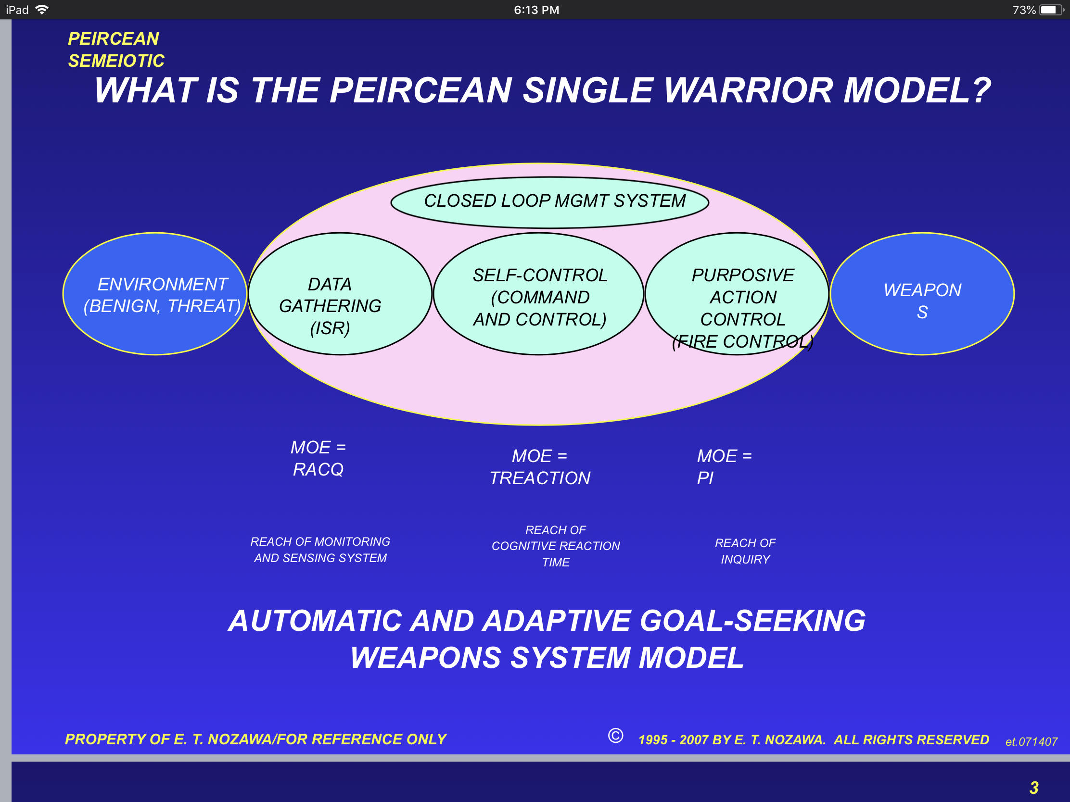

The topic of fully autonomous weapons systems has come to the fore in ethical conversations regarding weapons development, for example the on-line community of AI developers against fully autonomous weapons, https://autonomousweapons.org/. However, this is a recent topic of conversation among Weapons and AI developers. This slide originally from 1995 predates these conversations by some two decades. The question we have to ask is: was automation and cybernetic control put into play in tandem with Neuroweapons, automated thought injection based on machine learning algorithms and situation management. One need not look too far for imaginative nightmare scenarios from Hollywood for such a situation of automated neurowarfare.

- Genetic Algorithms founder, John Henry Holland was inspired by Piercean logic. See also the work of Matthew Kabrisky for USAF ‘ATR’ fusion. He is mentioned by Norseen. Matthew Kabrisky: 'A Proposed Model for Visual Information Processing in the Human Brain.' Michael Senglaub, PhD, colleague of Nozawa at Sandia National Laboratories, owned by Lockheed-Martin. ‘Knowledge Representation in Reasoning Systems’ and ‘C2 for Complex endeavors Automated Decision Support in a Complex Information Space’.

Troubling is the connection of Sandia Researchers, who worked directly with Nozawa as a consultant to their work, that specialize in ‘Network Assurance and Survivability’ such as Michael Senglaub[15] and their being influenced by closed loop automated controllers under Nozowa’s Piercean model. Meaning that if system designers for say nuclear missile defense, systems designed to withstand end-of-world conflicts continue operating on their own without human intervention based on the Piercean models then they could continue fighting wars after there are no more humans to fight. In this case we have a clear example of a situation of loop controllers and engineers such as Senglaub and Nozawa using loops to control weapons systems. Senglaub in the applications section of his research paper[15] suggests using the Piercean model for Data Fusion, Anti-Terrorism, Cognition-Based Decision Making and Autonomous System Control. Thus, possibly in their designs they have integrated Closed Loop Management Systems, which is to say fully automated weapons systems which also may integrate Holland’s Piercean Genetic Algorithms, self-writing algorithms [see below].
An additional element to the research conducted by Sandia[16] is that of using game theory to be deployed within the systems [see deeper discussion of Simulation AI in AI and Games section]. Thus with the integration of games into defense systems we have a computational model that could be invoked which is based purely on mathematical conditions that claim to model the real world, but fall short of it.
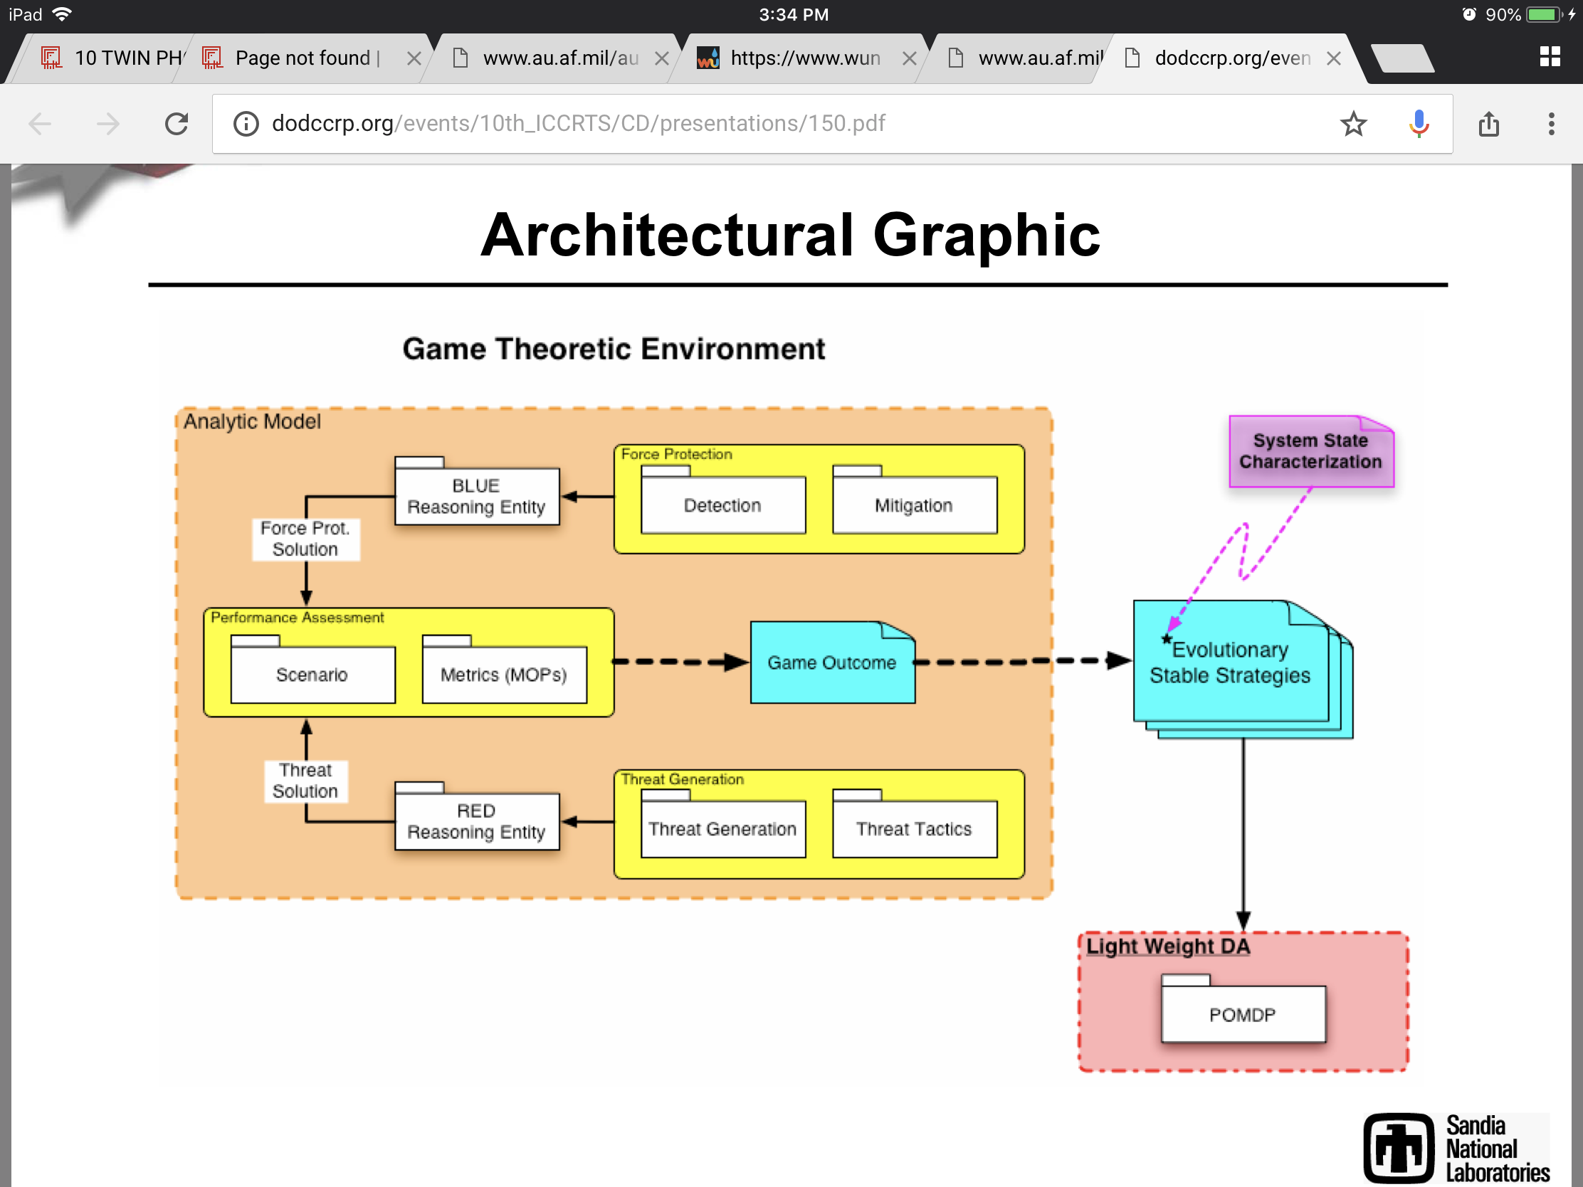

------------------------------------------------
Problems with Using POMDP architecture:

Remark 1 (consistency and dimensionality). All previous errors decrease with a rate Oe(1/ p N(l)), showing the consistency of the spectral method, so that if all the actions are repeatedly tried over time, the estimates converge to the true parameters of the POMDP. This is in contrast with EM-based methods which typically get stuck in local maxima and return biased estimators, thus preventing from deriving confidence intervals. (Azizzadenesheli, 2017, 5) https://arxiv.org/pdf/1705.02553.pdf Experimental results : Reinforcement Learning of POMDPs using Spectral Methods

-----------------------------------------------

Graphic from Senglaub presentation which is similar to contemporary Generative Adversarial Networks architecture. This was initially presented in 2003 in the Journal on Reflexive Control by an American team of researchers, pictured previously, from NMSU RTRT group.[25] We can see the direct influence between Seglaub’s work and that of the group:

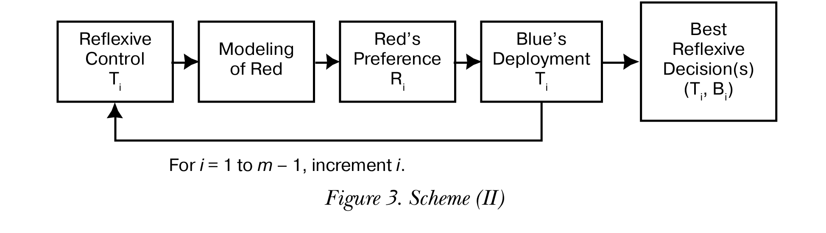
It is an interesting point of understanding that this conception of adversarial networks predates the innovations in contemporary Artificial Intelligence, introduced by Ian Goodfellow in 2017, so that we see the pre-dating of what is considered cutting edge AI techniques in the public sector by at least 15 years in the defense industry. As is indicated in Senglaubs graph, POMDP (Partial-Observable Markov Decision Process), of which is of interest to GANs and Deep Reinforcement Learning as ‘breakthroughs’ in AI techniques in such applications of using AI to compete against human competitors in Real-Time Strategy Games (RTS), such as what is viewed as the elite public application of this techniques at London based Deepmind. We can see that there is a clear technological lead in the compartmentalized covert world compared to that of the public domain. Which as we shall see later, is also of interest to Quantum Computation, where just in the last 2 years QC simulations have become public but written of by Defense researchers some 20 years ago.

The main theoretician on Semiotic Games is Lefebvre at the University of California. He states regarding his semiotic game theory:

Traditional game theory is a normative science and is not meant for modeling the real behavior of players. This paper describes a method the goal of which is to predict the choices of players in real situations rather than to compute optimal decisions. It is assumed that each player faces a choice between two strategies: active and passive. The method is based on structural representation of a subject together with his images of the self and another. This representation allows us to compose systems of equations whose solutions are the probabilities with which the players choose the alternative strategies.[21]

Senglaub presents his ideals on Evolutionary Game Theory as:
• Essentials of Evolutionary Game theory.
– Non cooperative game.
– Played many times.
• “Players” are randomly drawn from a population.
• Each member of the population can have a unique strategy.
– Evolutionary process impacts the population from which players are drawn.
– No guarantee that the ultimate strategy will lead to a Nash equilibrium.

Usually in a game there is what is known as a Nash equilibrium being reached.
Nash Equilibrium:

In terms of game theory, if each player has chosen a strategy, and no player can benefit by changing strategies while the other players keep theirs unchanged, then the current set of strategy choices and their corresponding payoffs constitutes a Nash equilibrium.
Stated simply, Alice and Bob are in Nash equilibrium if Alice is making the best decision she can, taking into account Bob's decision while his decision remains unchanged, and Bob is making the best decision he can, taking into account Alice's decision while her decision remains unchanged. Likewise, a group of players are in Nash equilibrium if each one is making the best decision possible, taking into account the decisions of the others in the game as long as the other parties' decisions remain unchanged. (Wikipedia, re-write or swap out later)

It is ominous that in an possibly autonomously controlled system that no nash equilibrium could be reached. He brings forth a co-evolutionary strategy that is fully automated, in other words weapons systems controlled purely by a Computer system.

Co-Evolutionary Game Theory
• Multi-sided game in which all sides evolve a dominant strategy.
– Is evolutionary game theory with n evolving players. • Objective
– Provide basis for an automated system to search for optimal solutions against adaptive opponents.

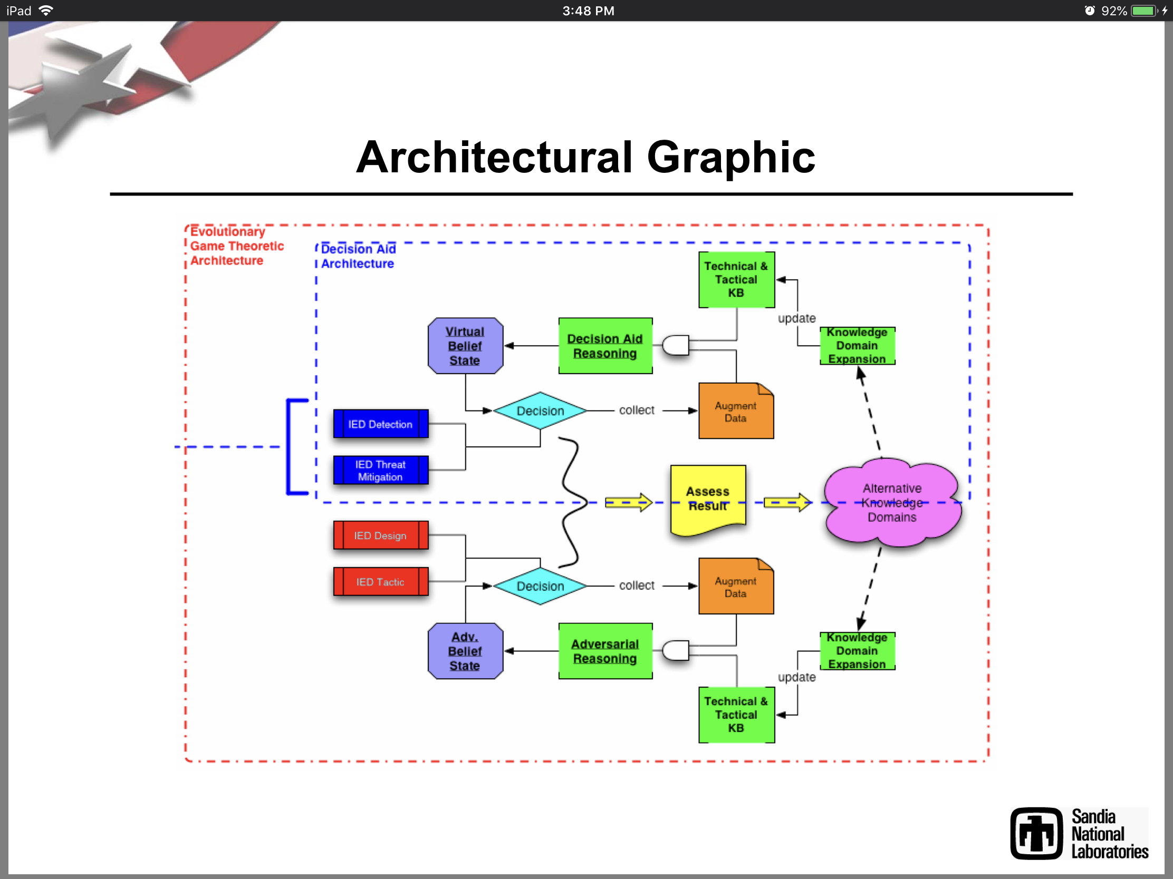

As was mentioned previously the technological edge rests with the covert science compared to open-source open-domain technologists. One such area of interest is that of Quantum Computation [for a further discussion see Quantum Computation section]. It is interesting that many years before that Defense related computer scientists were already exploring QCs to implement automated decision making:

A quantum device simulating the human decision making process is introduced. It consists of quantum recurrent nets generating stochastic processes which represent the motor dynamics, and of classical neural nets describing the evolution of probabilities of these processes which represent the mental dynamics.The autonomy of the decision making process is achieved by a feedback from the mental to motor dynamics which changes the stochastic matrix based upon the probability distribution.This feedback replaces unavailable external information by an internal knowledge-base stored in the mental model in the form of probability distributions. As a result, the coupled motor mental dynamics is described by an online version of Markov chains which can decrease entropy without an external source of information. Applications to common sense based decisions as well as to
evolutionary games are discussed. An example exhibiting self-organization is computed using quantum computer simulation. Force on force and mutual aircraft engagements using the quantum decision maker dynamics are considered.[22]

It is well known to computer scientists that Quantum computation gives one an incredible step up in terms of computational power, it would be hard for a classically based computer to implement an advanced algorithm for such decision making in a complex environment such as the fog of war (incomplete information, dynamic, etc) but not for a Quantum Computer.

Another area that has influenced Intelligent Systems and automation is that of Genetic Algorithms or Genetic Programing, which is based on Natural Genetic Selection, where a computer compiles it’s own components and finds the best fit among various modules to formulate a optimal choice. This area was strongly influenced through Piercean Logic in the founder of Genetic Algorithms, John Holland of the University of Michigan. It was also advocated by Senglaub in engineering Automatic systems. Senglaub writes:

Genetic programming or evolutionary programing technologies could also provide insight into design configurations that could result in fault configurations under sets of environmental drivers. recognizing the basic elements of the design configurations and introducing specialized “abnormal environment” operators, genetic programs(GP) could be tasked with finding all possible fault configurations that result in unacceptable states for a sub-system. A great deal of work has been performed in which GP’s have been tasked with designing circuits, structures, and algorithms. [26]

In artificial intelligence an agent is used to formulate optimal solutions. A more generalized definition of Semiotic Agents (SAs) is given:

Thus in turn the possible decisions that agents can make must be considered relative to those possible actions. The result of all of this is that SAs can be cast in terms of a generalized control architecture, as in the work of Powers [1973, 1989], where the autonomy of the system is allowed by its manifestation of a closed causal relation with its environment. Through this relation the agent makes decisions so as to make its measurements (representations of current and past decisions and states) as “close” as possible to its goals in order to reduce a generalized “error function” given by its own beliefs of what desirable states are. Thus, as illustrated in Fig. 2, SAs manifest a generalized negative feedback control relation.[17]

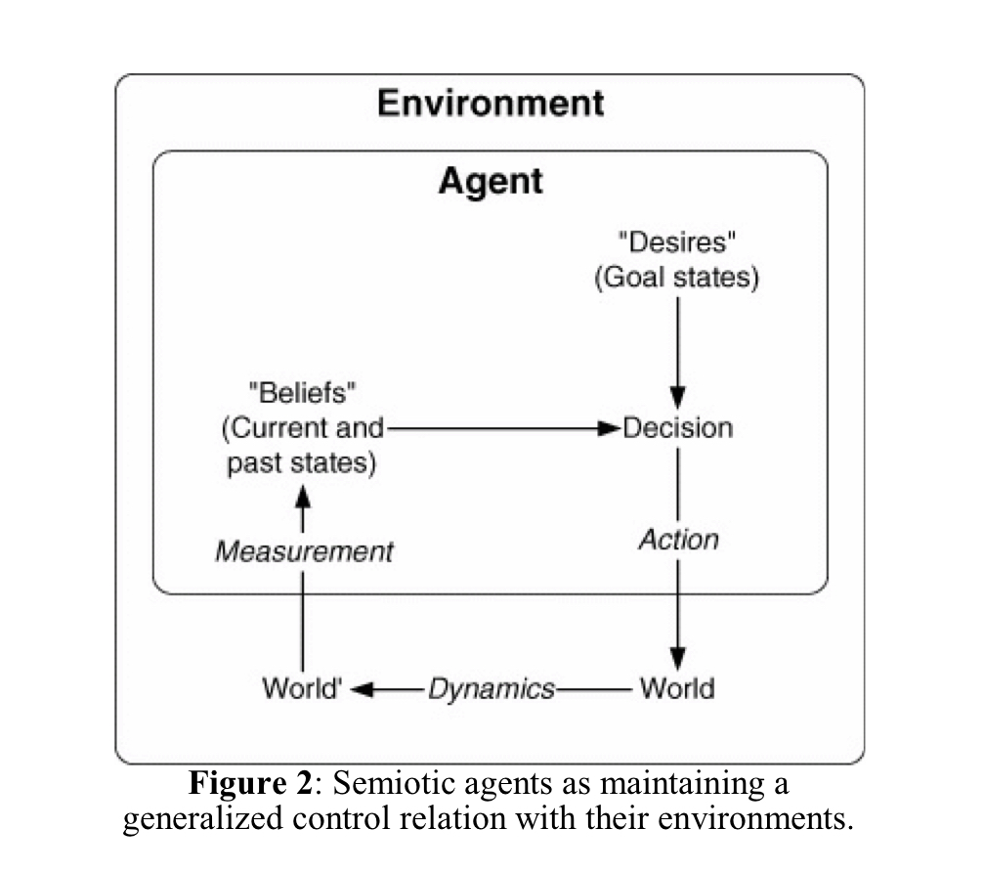

Lockheed-Martin is not alone in seeking to use Semiotic Cybernetics in their defense systems. Saab Microwave Systems, for example, also is relying on Automated Intelligent Systems, possibly also influenced by Piercean Logic as tech is often copied by one company to another, to manage their defense infrastructure. It is interesting and directly related to Neuroweapons as their systems oversee Radar and Microwave infrastructures which are both directly related to the technologies of Neurowarfare. In a presentation on-line by Saab Scientist, Hakan Warston , they show the progression in their thinking and what they view as a necessity of relying in the future on automated computer decision making systems.[18].

Use of Automation up to 2015:
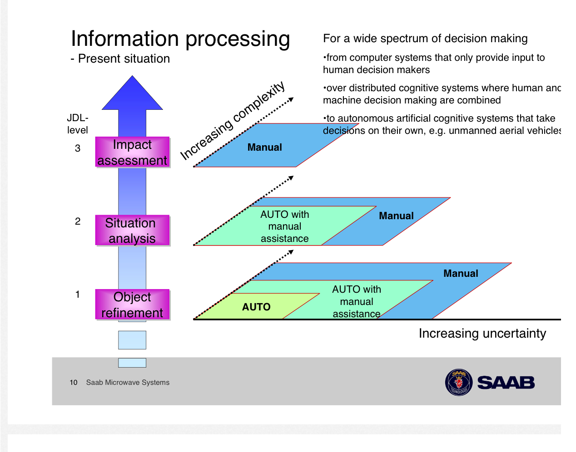
Projected Automation from 2015:
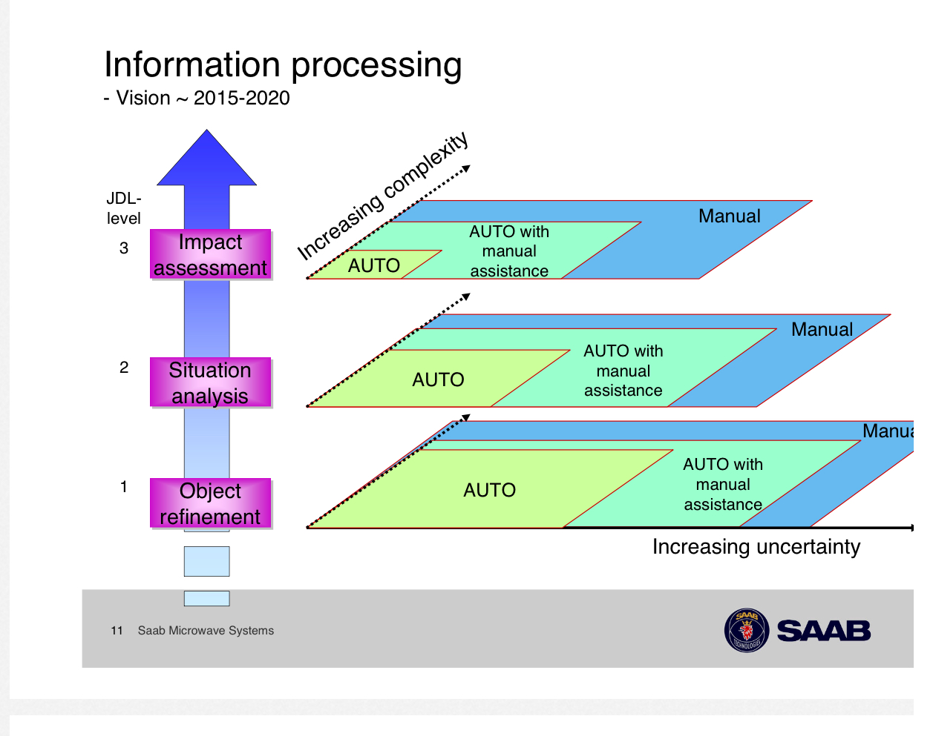

As one can plainly see from the slides at the time of their writing relies a great deal less on automated with manual assistance and very small footprints of fully automated. However, from 2015-2020 they foresee a large footprint for fully automated computer decision making in their systems. I would imagine that Saab Microwave Systems is not alone in this trend.

Of course such concepts as Reflexive Control, Thought Injection and other methods of this weapons technology would be incomplete without a grounding in Brain Computer Interfaces [see discussion in AI section]. Dr. Norseen cites two researchers related to this field. One a Russian scientist that works for the US Government, Alexei A. Sharov, cited by Norseen. Also, the work of an American who worked for the Office of Naval Research, Richard H. Dickhaut, under the working title of ‘Neuroelectric Activity and Analysis in Support of Direct Brainwave to Computer Interface Development’. From which Norseen developed his techniques for mapping the Brain. Another researcher is that of Russian emigre Alexei A. Sharov who specializes in Biosemiotics and Cybernetics for the US Government. He writes regarding this convergence:

Another Norseen cited researcher is that of Robert Asher, also of Sandia Labs, that is specifically working on Brain-Computer-Interfaces a briefing by him from 2003 reads:

Human performance enhancement may require modifications to th e biochemical aspects of the human. Maintained alertness, enhanced physical and psychological performance, and enhanced survivability rates in serious operations all require modifications to the biochemical aspect of the human. DARPA is in the process of developing drugs to enhance performance when a person has been sleep-deprived.

Consider the use of externally applied, non-dangerous electromagnetic fields to increase the rate of production of body biochemicals that enhance human performance. DARPA has a proposal to increase the rate of stress protein production before a soldier goes into combat. The intent is to increase the survivability rate when the soldier is wounded and needs to receive blood products. Beyond that, one can envision increasing the rate of production of ATP [triglycerides in fat cells as power booster?], which will yield higher energy levels by natural means, will help ion pumping to aid in nerve recovery and contraction of muscles, and will speed recovery from combat stress. What other changes can be engineered by a specifically shaped electromagnetic pulse that might enhance human performance without pharmaceuticals? This investigation may spawn a new industry in which the human is enhanced by externally applied electromagnetic pulses so shaped as to enhance specific biochemical changes within the body without drugs or in combination with drugs, with fewer side effects. For instance, nanoparticles might be formulated to release drug dosages…
(Asher, 355, 2003)

It is not hard to see through Asher’s work that when using electromagnetic pulses to increase combat readiness one would have to monitor each soldier in combat to increase their biochemistry, it of course would be impossible to do this manually, which would mean that it would take a Intelligent System controller to oversee the mass number of troops in combat to increase their biochemistry, and if this is connected to a Automated system then it is not hard to see how this could also be done on a mass scale covertly. For Norseen’s project then they would be able to use electromagnetic stimulation to ‘lobotomize’ a terrorist with dual usage always in view. Asher continues on the different applications of electromagnetic stimulation:

Nano. Develop and understand the nano aspects of the use of electromagnetic field interactions with cellular structures. Develop and understand how treatments may be developed by nano particle interactions only at specific sites where the electromagnetic fields are focused. Investigate whether electromagnetics can be used as a power source to conduct mechanical actions at the sites.
Bio. Develop a detailed understanding of the effects of electromagnetics on cells and neuronal networks, including the full range of scales, from micro effects on proteins to macro effects on neuronal networks.
Info. Develop methods to shape optimal electromagnetic pulses to carry messages to the cells and neurons.
Cogno. Understand how electromagnets can be used to enhance cognitive performance as well as physiological performance.
(Asher, 356, 2003)

This is an alarming development from 2003 if they have in fact developed nanotechnology to enhance or control human performance then ordinary biological humans could be very realistically turned into cyborgs without any visible mechanics. And it is very clearly that this is inline with the Norseen Semiotic vision of Information Injection. In this report of Asher in the section under Brain-Machine-Interfaces he sees the applications of this technology to mass control of automobile drivers or air traffic controllers, again we see the convergence with Radar in this technology. As many civilian complaints of neuroweapons abuse there are many statements related to being stalked by vehicles on the road, Asher writes;

The DARPA program could be extended to include a broader range of potential impact by including the possibility of other applications: learning and training, automobile control, air traffic control, decision-making, remote sensing of stress, and entertainment. Learning and training might be implemented as information coded into brain signals and then input into the person. Air traffic control in increasingly busy skies can use such capability: the controller has multiple inputs from multiple aircraft. These can be input into his brain in a 3 -D aspect and an alertness signal used to “wake him up” when his attention drifts beyond acceptable limits. Not only intellectual data might be passed from one person to another without speaking, but also emotional and volitional information. Decision-making may become more precise as emotional, fatigue, and other cognitive states can be appraised prior to making a critical decision.
The potential impact on automobile safety is great. The driver can have quicker control of his automobile ( Figure E.1 5), allowing for safer driving while reducing the car- to-car spacing on congested highways. This would help alleviate highway congestion and the need for more highways. Furthermore, it would allow for safer driving as driver attention can be measured and the driver “alerted” or told in some manner to pay attention to his or her driving when attention wanders beyond safe margins. It can allow for detection of driver impairment so that the vehicle may be made either not to start or to call emergency. (Asher, 357, 2003)

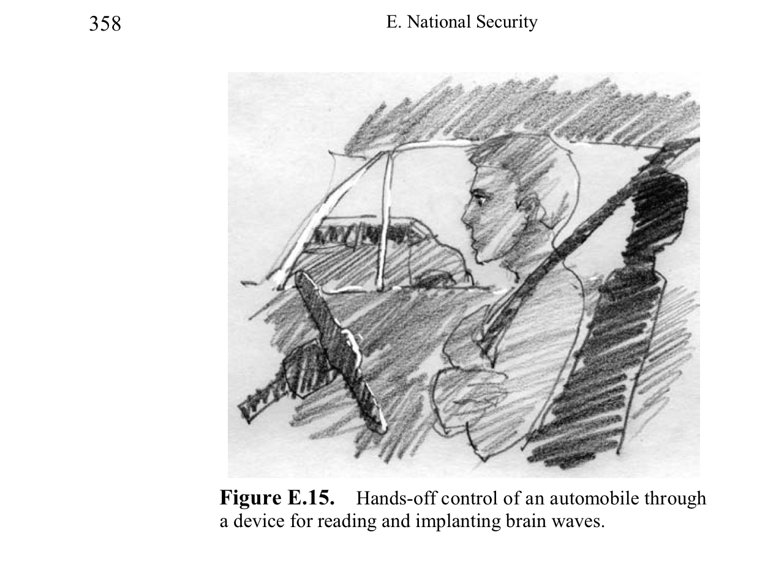

Semiotic Diplomatic Cybernetics
Increasingly we are seeing the use of Intelligent Systems to model various social relationships. One field where this has entered into the convergence between technological and social spaces is that of International Relations. The use of Intelligent Systems to not just model but control and interact with international relations is related:

The second procedure, called long range, strategic control reflects a longer term planning of policy changes that are implemented consistently throughout the whole evolution. The long term strategic control is achieved by an optimal control algorithm that we briefly discuss in Section 4. In the optimal control framework the perturbations (controls) are evaluated in order to minimize or maximize some objective functional that depends on the state and the controls. The actual form of this functional essentially depends on the goal we want to achieve and explicitly includes the reward and cost of that goal. The main advantage of such planning is that the changes one has to implement are known over the whole time span of the system's evolution and provide an optimal solution (an optimal cost effectiveness is realized for attaining the desired goal). The basic disadvantage of this method is that modeling errors, inherent perturbations, and unforeseen factors will usually lead to a trajectory different from the planned one. pg 349

This approach is based on the optimal control method applied to discrete systems. The optimal control method can be simply summarized as follows. The system is described by a scalar or vector state function depending on a number of independent variables that take values in the phase space of the system. The state satisfies a (usually nonlinear) dynamical scalar or vector equation that depends also on some parameters that take values in the parameter space. One or more of these parameters are considered external controls to be adjusted at will. The goal is to optimize a given objective func-tional that depends on the state and on the control(s). pg 351
From the state equation and objective functional one constructs, in a canonical way, a non-homogeneous adjoint equation for a (scalar or vector) adjoint variable. The original state equation together with the adjoint equation form the optimality system (OS). The optimality condition yields an explicit, analytical formula for the optimal control in terms of the solutions of the OS. By replacing this expression of the control in the OS and solving it, one obtains the optimal state and adjoint variable and therefore the optimal control. The general framework for optimal control for general nonlinear systems as developed by J.-L. Lions was recently applied to competitive systems of social and military interest pg 352

The long range control is better suited when one has a good idea about global strategic objectives, the costs involved and, one wants to achieve a well-defined goal. Since the role of the user is essential in deciding what control strategy to use we see here an excellent example of applied semiotic analysis to international relations.[20] pg 352

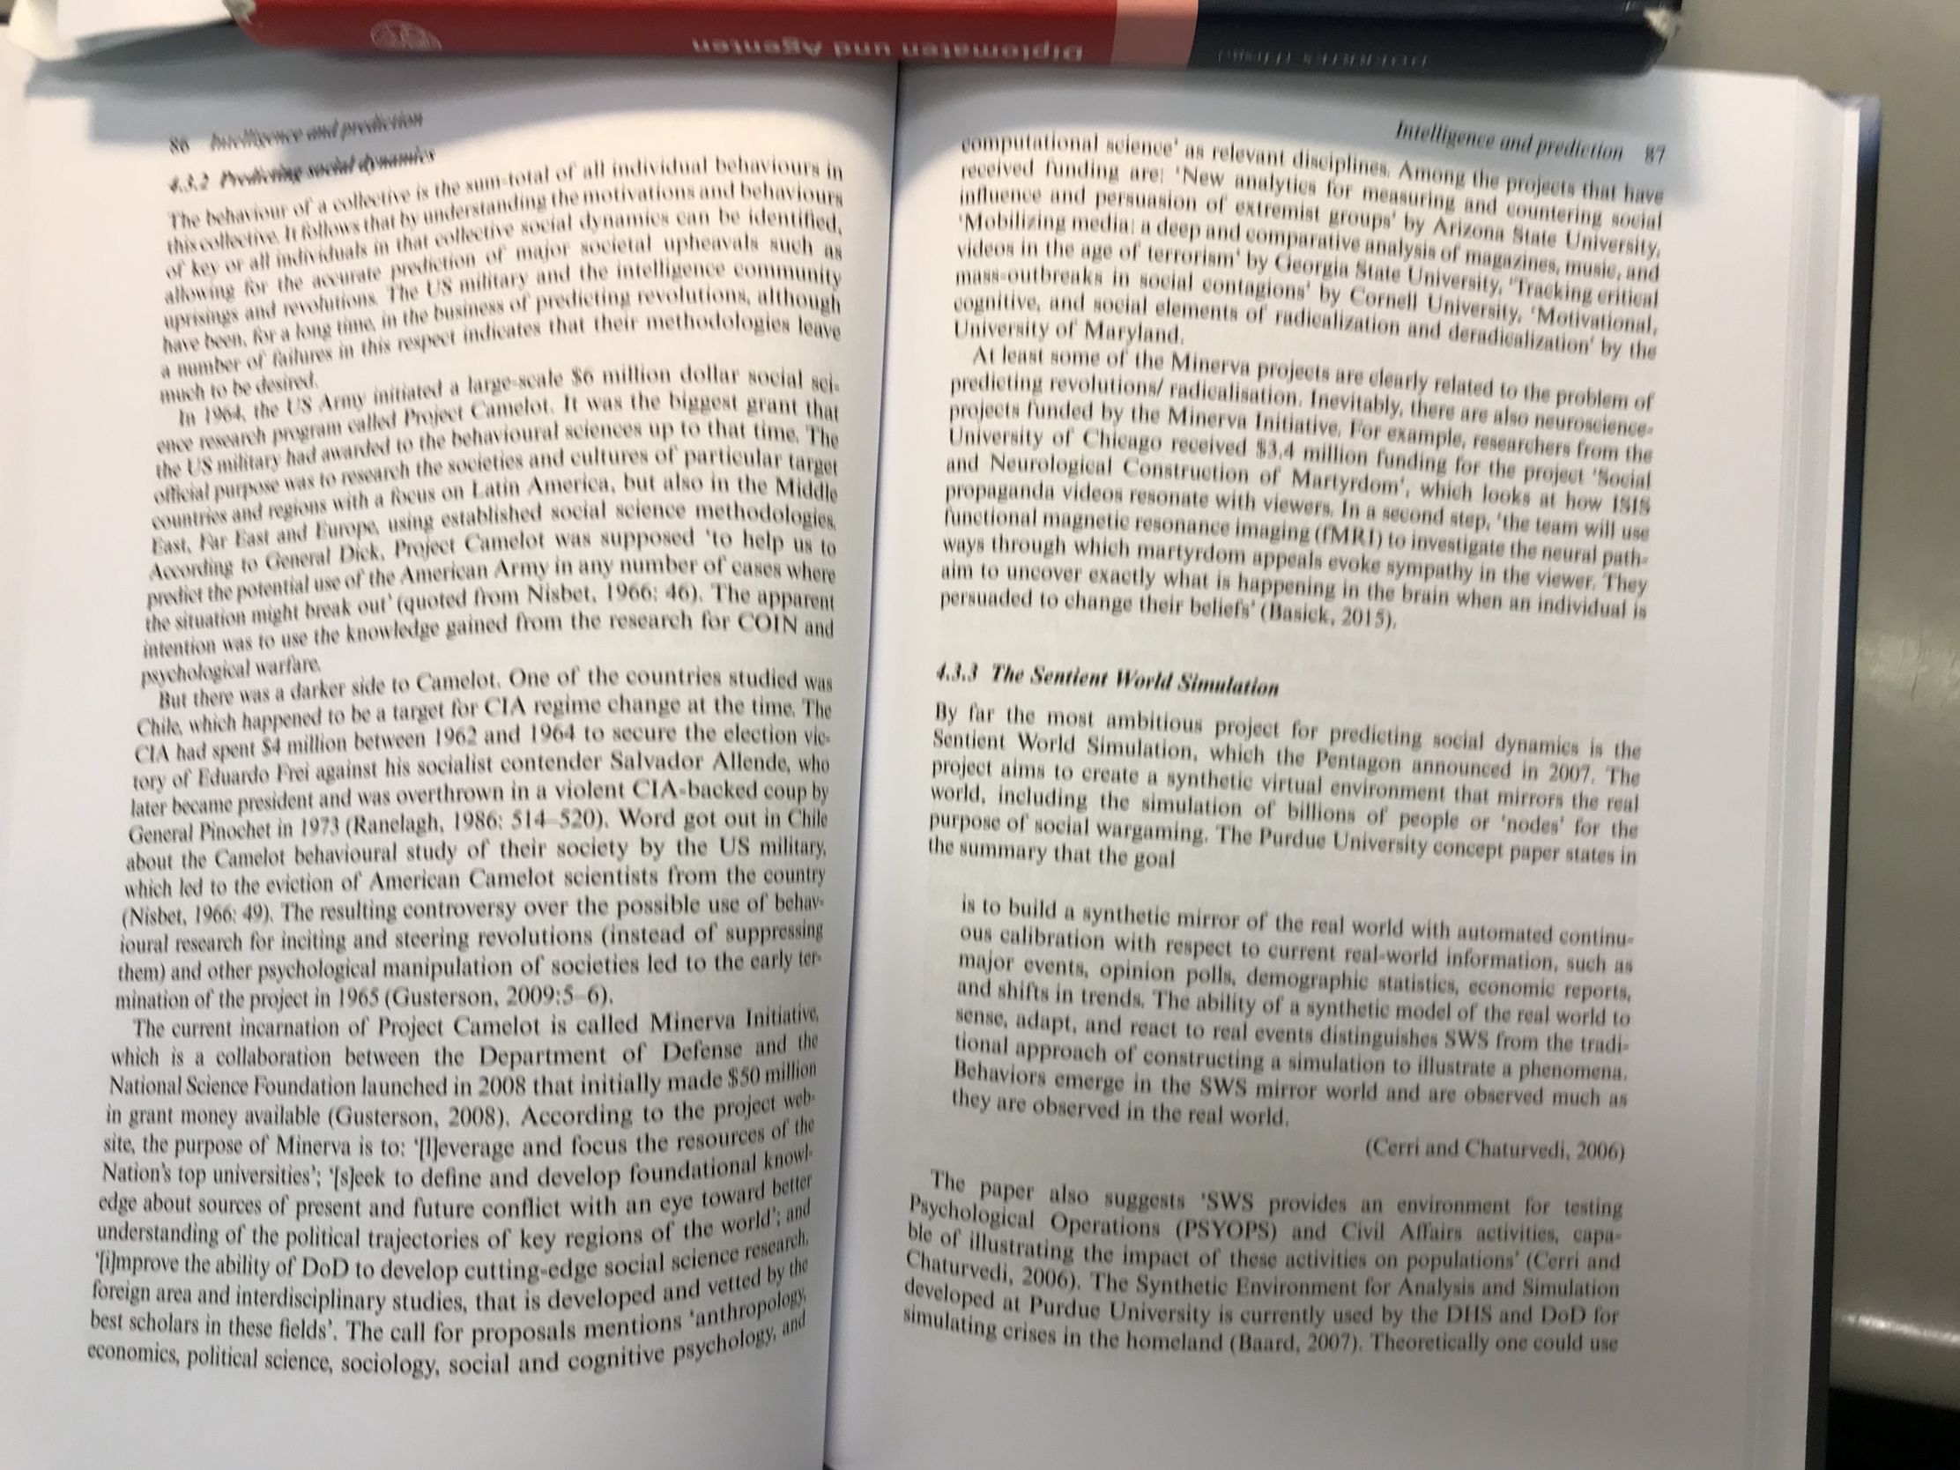

Semiotic Alcohol
Dr. James Giordano, a DOD specialist in neuroweapons and lecturer at George Washington University, like Norseen and Umpleby, has written regarding what are known as nootropics, bio-chemical agents affecting cognitive function. Norseen also talks about the use of nootropics with Laurie. He also in this dialogue explicitly implicates ‘the Brits’ as being the main party responsible behind starting research into this area. Perhaps, the most interesting take from what Norseen discusses with Laurie is what would normally be considered a Conspiracy Theory in relation to the mass shooters at Columbine in Colorado. He suggests that they were influenced by a remote thought injection system in another part of his discussion through websites, which may have used the 25th frame technique [see Neuroweapons discussion] or other methods of subliminal control and influence. In an a long passage from their conversations Norseen goes into a conversation hitting on the use of thought injection as a Weapon of Mass Destruction (WMD), one that he later goes on to view as a means of being implemented for that purpose, which of course should sound like a paranoid conspiracist if it were for the fact that he is a weapons designer working on these very systems for Lockheed-Martin and the National Security apparatus of the United States.

Norseen begins his discussion talking about nootropics:

Quoting Duncan: “My question is, what can that little pill, with its little molecules, contain that can cause such a radical shift in awareness?”
OH BOY! Now you have gone and done it. This actually gets into the DEEPEST, DARKEST SECRETS of my work; the Columbine Massacre….wet ops [assassination] in England [perhaps a reference to the Marconi Murders]…..the next, absolute WMD (information control is the ultimate weapon of mass destruction)
Information Injection - Weapon of Mass Destruction
And now you get me going into the kinds of Little White Pills that are being made in Porten Downs [UK Biochemical Production facility] and in the Russian labs and other places I am familiar with...and you are coming up with MK-809 in Germany and a special little breed I am working on that heads directly for each of the 5 main pain receptor sites in the Central Nervous System...alpha, epsilon, delta, kappa, and mu.
You can easily think of the brain as simply a NITROGEN MOLECULE RESONATOR, and this is the currency by which the ZPE comes pumping in to humans. It is also how the anti-depressants and the REBOUND drugs work, in the Larium, and the Luvox, etc. etc. It is how the DOOM web sites [video game portal used by Columbine shooters] get the SIGNAL into the receptive minds of th the ATTACHED, and dispatches them...with the ultimate act already PRIMED and LOCKED and LOADED into the Superior Colliculus...and when the final signal arrives, the SC takes over and Wham…suicide, or info induced wet ops. (Noseen, Laurie Part 11)

Norseen here directly talks about the influencing of minds through nootropics, stating that Nitrogen (N) is the key to unlocking Wiring in the brain and leading to changes in function which is to say human behavior. Again we see his notion of unlocking the functions in the brain, QSK. He uses the example of the Columbine shooters here to illustrate his point, which may sound like irrational rambling. It is interesting to note that in the Snowden Leaks it was discovered that GCHQ and the NSA infiltrated video game communities to do behavioral studies. So it may not be as far fetched as we may think, especially with the knowledge of illicitly and illegal biological tests done on unknowing civilians in the history of National Defence research in the United States.

Norseen then goes on to discuss where it originates, he directly implicates the United Kingdom in this research going back he says 100 years. He talks of a biomolecule Tetrahydroisoquinoline (TIQ or THIQ) an organic compound with the chemical formula C9H11N.

OK, OK...where did this all come from...The Brits and their work with the opium trade wars...and also the fear of drug-induced attacks on the Royal Marines that the big bore and higher caliber ammunition couldn't stop…what is the cause?...the Brits still classify all the work in THIQ...now it happens that THIQ is even more powerful than MK-809 and along the lines of my Designer register.
When a drunk becomes a Stage 4 alcoholic, the body and the brain actually convert body chemicals into THIQ...tetrahydroquinine, etc. and the THIQ can actually be found as little white crystals and powderize crystals in the brains of dead alcoholics. The BRITS began over 100 years ago to administer this to see the effects and they found it was 1000x more powerful than morphine (it is even more powerful than fentnyl, the gas used by the Russian 'vimple' antiterror squad to squash the Chechnyan take over of NordEst in Moscow…(the Brits gave the fentyl to the Russkies) and it knocked everybody out in less than 10 seconds...well, THIQ is 100x or more powerful than that...it is what the alcoholic produces to keep him, or rather, his Brain, alive
So in the brain...you have 99% driving for WILD LIFE...and 1% set up to BLANK OUT. And in between are the LITTLE WHITE POWDERS - the PILLS, the 7% laudanum solutions.
(Norseen, Laurie Part 11)

THIQ was thought at one time to be the cause of Alcoholism, however, this was later disproved, it is rather a product of Alcoholism according to Norseen. This is an interesting connection, in fact we have already seen how Alcohol was related as a trance agent in an earlier passage in the Norseen and Laurie in regards to Norseen’s encounter with Russian scientists. It is a question if he had a scientific purpose in discussing THIQ or to what ends other then as an example of a substance that can alter human behavior. He continues with the discusson of THIQ:

Information as a Drug Delivery Device
And back to THIQ...for a while the British medical corps was using the THIQ for battlefield ops and the patients were getting up and going back into battle with no arms and legs and such and they realized…this stuff is beyond TOP SECRET. What if the enemy gets this...our .45 to the head won't stop them from coming over the walls...so the Brits SEALED IT DEEP AWAY and got the US to “fogitdabowdit”. Until certain agency souls started to play with it again and it slipped out…hence the race to Oxycontin… pure female birthing neurotransmitter Oxytocin...I like the spelling changes myself...to MK-809, to new Fentnyl, to my new Designer Formula… (Norseen, Laurie, Part 11)
Here Norseen discusses an interesting opiate Oxycontin, which has become an epidemic in places like the United States in terms of addiction. Other countries developing Neuroweapons, such as Nazi Germany, also had major opiate addictions, for instance IG-Farben created methamphetamines [see Neuroweapons section]. It is also of interest that he relates this to the ‘female birthing neurotransmitter Oxytocin’. Oxytocin is a peptide hormone and neuropeptide. It is most important in birthing and nurturing young (social bonding) of mothers to children, it is produced in the hypothalamus and released by the posterior pituitary glands. It is interesting to note that civilians claiming to be affected by Neuroweapons, often termed ‘Targeted Individuals’ are comprised of 70% female. What role specifically Oxytocin and Oxycontin plays in this is not known to this author, but clearly Norseen as a weapons designer brings it up in the context of brain alteration. He continues:

Duncan...This page shows the chemical “resonating” structure of quinolines...the basic block that links into the neuronal synapses, the neuropil, of the brain and when locked in, the ZPE comes pouring in…and you are the signal...pain goes away and is replaced by the Semiotic. Do you see the BIG FAT “N”? That is the nitrogen resonance....by playing around with the N...you can create all kinds of signals.(i.e. realities) in the brain...That is what your little white pill does...why it is so powerful...it plays the HAARP of the N - and transports you to wonderful new worlds....

He discusses the role of Nitrogen in the resonating structure of quinolines. [elaborate more on this, more researc needed]

Semiotic Prophecies of Dr. John Norseen

Perhaps in the most ominous aspect of his conversations with Laurie, Norseen elaborated on what he perceived as a doomsday outcome of this technology and warfare in general. He directly linked this to overpopulation and migration:

As we approach 500 million people in 2025 [in US population] and the nasties start flying, we are going to lash out at the world and “waste ½ of it” — if you look very carefully at the Semiotics that are being impressed on our culture you can see “Total War” as the dominant theme. F the UN, “just waste em” will be the mindset.
(Norseen, Laurie, 2002, part 15)
And yes, there are technologies already set up in advance, pre-positioned for the future border semiotic wars — rapid fire Stego Bullets, brain specific prions, multi-channel semiotic PSYOP — I can believe when people say they have signed documents concerning non-disclosure for 70+ years...I inked such forms myself.
(Norseen, Laurie, 2002, part 15)

Mind you this was written in 2002, and approaching 20 years later we see this reality unfolding as climate change has put pressures on growing populations around the globe, leading to migrations, which has led to a rise in Nationalism, and Border Walls, or as Norseen put it ‘future border semiotic wars’. One can only imagine how fantastical this conversation must seem to an uninformed audience over the years, however, to those living some time after this conversation as public disclosure regarding neuroweapons and with the changing climate, it is more and more realistic.

-----------------
Notes:
[1] http://www.acsa2000.net/john2.html
[2] get source from Krishnan book, online archived at http:///web.archive.org/web/2001/www.angelfire.com/or/mctrl/Norseen.htm (accessed 5/17/19)
[3] Murray, Frank J., ‘NASA plans to read terrorist’s minds at airport’ Aug 17, 2002, archived on-line at https://twoday.net/static/mindcontrol/files/zimmermann_and_norseen.htm
[4] https://cypheragablog.wordpress.com/category/introduction, posted Sept. 15, 2010 (accessed 4/17/19)
[5] Total Information Awareness (TIA) was a project of the National Security Agency to have all known information about an individual and a society, totally. It is interesting that Norseen mentions it here was part of his research viewed as part of TIA?
[6] https://www.rand.org/topics/information-operations.html (accessed 5/18/19)
[7] http://www.au.af.mil/au/awc/awcgate/milreview/jones_perception.pdf (accessed 5/18/19)
[8] Ryan Moore, http://www.militarytransition.com/, 2003. ( Offline as of July 2010. February 2005 snapshot on archive.org )
[9] Norseen cites this contract as his funding vehicle for research, part of his research was used in connection to Human-Sensor interactions in aircraft pilots: Lockheed Martin Aeronautical Systems, AvCS, Inc.: Data Communications Requirements, Technology and Solutions for
Aviation Weather Information Systems, Phase I Report - Aviation Weather Communications Requirements. NASA Contract N66001-97-C-8605, March 1999. (Cited in Norseen 2000)
[10] See more at http://www.pravdareport.com/news/russia/25537-n/” (accessed 5/20/19)
[11] Thomas, Timothy L., ‘Russian Reflexive Control Theory and the Military’, Journal of Slavic Military Studies 17: 237–256, 2004 Copyright © 2004 Taylor & Francis ISSN:1351-8046 DOI:10.1080/13518040490450529 https://www.rit.edu/~w-cmmc/literature/Thomas_2004.pdf (accessed 5/20/19)
[12] Koruga, , ‘Microtubular Screw Symmetry: Packing of Spheres as a Latent Bioinformation Code’ in Annals of the New York Academy of Sciences 466(1 Dynamic Aspec):953-5 · February 1986
[13] Burch, Robert W. The VINITI Program, Army Research Laboratory, ARL-CR-212, June 97.
[14] He cites from 1999 the papers of: Workshop on Multi-Reflexive Models of Behavior, V. Lefebre, ARL-SR-64, May 1999. Reflexive Control in Multi-Subjective and Multi-Agent Systems, V. Lepsky, ARL-SR-64, May 1999. In Norseen 2000
[15] Senglaub, Michael. ‘Foundations for Reasoning in Cognition- Based Computational Representations of Human Decision Making’ SANDIA REPORT SAND2001-3496 November 2001
see, http://www.au.af.mil/au/awc/awcgate/decision/raybourn-senglaub_013496.pdf (accessed 5/21/19)
[16] Senglaub, Michael, Harris, Dave. Sandia National Labs, SAND2005-2938C, ‘A Modified Perspective of Decision Support in C2’,
June 14, 2005 see http://dodccrp.org/events/10th_ICCRTS/CD/presentations/150.pdf (accessed 5/21/19). Original Red/Blue design from 2003 in http://www.reflexion.ru/Library/EJ2003_1.pdf (accessed 5/22/19).
[17] TOWARDS SEMIOTIC AGENT-BASED MODELS OF SOCIO-TECHNICAL ORGANIZATIONS
Cliff Joslyn and Luis M. Rocha
Computer Research and Applications Group (CIC-3)
Los Alamos National Laboratory
MS B265, Los Alamos, New Mexico 87545
{joslyn,rocha}@lanl.gov http://www.c3.lanl.gov/~{joslyn,rocha}
Citation: Joslyn, Cliff and Luis M. Rocha [2000]. "Towards Semiotic Agent_Based Models of Socio_Technical Organizations." Proc. AI, Simulation and Planning in High Autonomy Systems (AIS 2000) Conference, Tucson, Arizona, USA. ed. HS Sarjoughian et al., pp. 70-79. See https://www.informatics.indiana.edu/rocha/publications/ps/AIS00.pdf (accessed 5/21/19)
[18] Warston, Hakan. ‘System Situation Awareness in Network Based Command & Control Systems’, euCognition Meeting Munich, January 12, 2007 http://hobbydocbox.com/Art_and_Technology/68615758-Situation-awareness-in-network-based-command-control-systems.html (accessed 5/21/19)
[19] Tarasenko, Sergey. ‘The Inverse Task of the Reflexive Game Theory: Theoretical Matters, Practical Applications and Relationship with Other Issues’
Kyoto University, Yoshida honmachi, Kyoto 606-8501, Japan. See https://arxiv.org/pdf/1011.3397.pdf (accessed 5/22/19)
[20] Control Mechanisms for a Nonlinear Model of International Relations
Aron Pentek, Jim Kadtke
Institute for Pure and Applied Physical Sciences, University of California at San Diego, La Jolla, CA 92093-0360
Suzanne Lenhart
Mathematics Department, University of Tennessee, Knoxville, TN 37996-1300
Vladimir Protopopescu
Computer Science and Mathematics Division Oak Ridge National Laboratory, Oak Ridge, TN 37831 https://nvlpubs.nist.gov/nistpubs/Legacy/SP/nistspecialpublication918.pdf

Miller, L. D., Sulcoski, M. F., and Farmer, B. A., "Dis- crete Richardson Model: A Paradigm for International Relations?", preprint(1996).
look up miller oft cited in semiotic cybernetics

[21] REFLEXIVE GAME THEORY
Vladimir A. Lefebvre
School of Social Sciences University of California, Irvine CA 92697 37831 https://nvlpubs.nist.gov/nistpubs/Legacy/SP/nistspecialpublication918.pdf
[22] Quantum Decision-Maker Theory and Simulation Michail Zakab Ronald E.Meyers and Keith Deacon
Jet Propulsion Laboratory, MS126-347, Pasadena, CA 9109 California Institute of Technology, Pasadena,CA 9125 Army Research Laboratory, Columbia, MD21045
https://authors.library.caltech.edu/91471/1/97.pdf (accessed 5/23/19)

[23] Albus, James. Meystel, Alex. ‘An Introduction to Intelligent Systems and Semiotics’ National Institute of Standards and Technology http://www.dca.fee.unicamp.br/~gudwin/semiotics/semiotics.doc (accessed 5/25/19)
[24] Jaitner, M.L., Kantola, Maj. H., ‘Applying Principles of Reflexive Control in Information and Cyber Operations’ Journal of Information Warfare Vol. 15, Issue 4 (2016) https://www.researchgate.net/publication/311983748_Applying_Principles_of_Reflexive_Control_in_Information_and_Cyber_Operations (accessed 5/29/19)
[25] X.H. Kramer, T.B. Kaiser, S.E. Schmidt, J.E. Davidson, and V.A. Lefebvre, ‘FROM PREDICTION TO REFLEXIVE CONTROL’, in
REFLEXIVE PROCESSES AND CONTROL No. 1, v. 2, 2003. P. 86-102 http://www.reflexion.ru/Library/EJ2003_1.pdf (accessed 5/29/19)
[26] Senglaub, Michael. ‘Surety Theoretics’ https://digital.library.unt.edu/ark:/67531/metadc685377/m2/1/high_res_d/292814.pdf (accessed 5/30/19)
[27] Carl Clark Interview, https://www.stopeg.com/doc/CarlClarkInterview.pdf (accessed 4/3/19)

Bibliography:

Albus, James. Meystel, Alex. ‘An Introduction to Intelligent Systems and Semiotics’ National Institute of Standards and Technology http://www.dca.fee.unicamp.br/~gudwin/semiotics/semiotics.doc (accessed 5/25/19)

Asher, Robert, Sandia National Labs, ‘NON-DRUG TREATMENTS FOR ENHANCEMENT OF HUMAN PERFORMANCE’ in ‘Converging Technologies
for Improving Human Performance NANOTECHNOLOGY, BIOTECHNOLOGY, INFORMATION TECHNOLOGY AND COGNITIVE SCIENCE’
NSF/DOC-sponsored report
Edited by
Mihail C. Roco and William Sims Bainbridge National Science Foundation
2003 Kluwer Academic Publishers (currently Springer)
Dordrecht, The Netherlands. http://www.wtec.org/ConvergingTechnologies/Report/NBIC_report.pdf (accessed 6/2/19)

Berry, S. (2000), ‘Decoding Minds, Foiling Adversaries’, SIGNAL Magazine (October), p.5

Burch, Robert W. The VINITI Program, Army Research Laboratory, ARL-CR-212, June 97.

Clark, Carl Interview, https://www.stopeg.com/doc/CarlClarkInterview.pdf (accessed 4/3/19)

Deacon, Keith; Meyers, Ronald; Zakab, Michail. Quantum Decision-Maker Theory and Simulation
https://authors.library.caltech.edu/91471/1/97.pdf (accessed 5/23/19)

Dubrov, Aleksandr ‘Biogravitation and Psychotronics’ in ‘Impact of Science on Society’ UNESCO Volume XXIV, No. 4 ‘Parasciences’ Oct-Dec 1974

Jaitner, M.L., Kantola, Maj. H., ‘Applying Principles of Reflexive Control in Information and Cyber Operations’ Journal of Information Warfare Vol. 15, Issue 4 (2016) https://www.researchgate.net/publication/311983748_Applying_Principles_of_Reflexive_Control_in_Information_and_Cyber_Operations (accessed 5/29/19)

Joslyn, Cliff and Luis M. Rocha (2000). "Towards Semiotic Agent Based Models of Socio Technical Organizations." Proc. AI, Simulation and Planning in High Autonomy Systems (AIS 2000) Conference, Tucson, Arizona, USA. ed. HS Sarjoughian et al., pp. 70-79. See https://www.informatics.indiana.edu/rocha/publications/ps/AIS00.pdf (accessed 5/21/19)

Kadtke, Jim; Pentek, Aron; Lenhart, Suzanne; Protopopescu, Vladimir. Control Mechanisms for a Nonlinear Model of International Relations
https://nvlpubs.nist.gov/nistpubs/Legacy/SP/nistspecialpublication918.pdf

Koruga, , ‘Microtubular Screw Symmetry: Packing of Spheres as a Latent Bioinformation Code’ in Annals of the New York Academy of Sciences 466(1 Dynamic Aspec):953-5 · February 1986
[13] Burch, Robert W. The VINITI Program, Army Research Laboratory, ARL-CR-212, June 97.

Lefebvre, Vladimir. REFLEXIVE GAME THEORY
Vladimir A. Lefebvre
School of Social Sciences University of California, Irvine CA 92697 37831 https://nvlpubs.nist.gov/nistpubs/Legacy/SP/nistspecialpublication918.pdf

Lefebvre V.A., X.H. Kramer, T.B. Kaiser, S.E. Schmidt, J.E. Davidson, V.A. ‘FROM PREDICTION TO REFLEXIVE CONTROL’, in
REFLEXIVE PROCESSES AND CONTROL No. 1, v. 2, 2003. P. 86-102 http://www.reflexion.ru/Library/EJ2003_1.pdf (accessed 5/29/19)

Murray, Frank J., ‘NASA plans to read terrorist’s minds at airport’ Aug 17, 2002, archived on-line at https://twoday.net/static/mindcontrol/files/zimmermann_and_norseen.htm

Norseen, John D., Laurie, Duncan ‘Outlaw Technology’ (2002) published on-line at http://www.duncanlaurie.com/writing/outlaw_technology (accessed 3/6/2019)

Norseen, John D., Kropotov, Juri D., Kremen, Inna Z., ‘Bio-fusion for Intelligent Systems Control’ SPIE (The International Society for Optics and Photonics) Proceedings 12 March 1999

Norseen, John D. (1996) Images of Mind: The Semiotic Alphabet online: http://www.acsa2000.net/john2.html (accessed 3/3/19)

Norseen, John D. (2000) Mathematics, BioFusion and Reflexive Control
for Sentient Machines, Presentation for International Reflexive Control Symposium
(RC’2000) Russian Academy of Sciences – Institute for Psychology 17 – 19 October 2000 Moscow, Russia in Reflexive Control. Collected Articles. International Symposium. October 17-19, 2000. M. /Ed. by Lepsky V.E., Moscow, Institute of Psychology Press, 2000. 192 pages.(In Russian) online: http://www.reflexion.ru/Library/EJour_2002_1_b.htm (accessed 6/3/19)

Pasternak, D. (1997) ‘Wonder Weapons: The Pentagon’s Quest for Non-Lethal Weapons is Amazing, but is it Smart’, U.S. News and World Report, 7 July
--(2000) ‘John Norseen’, U.S. News and World Report, 10 Jan. vol. 128, no.1

Persinger, Michael A. (2015). The Graviton: An Emergent Solution From The Equivalence of Universal Magnetic Field Intensity and Radiant Flux Density. JOURNAL OF ADVANCES IN PHYSICS. 10. 2811-2815. 10.24297/jap.v10i3.1318.

Senglaub, Michael. ‘Foundations for Reasoning in Cognition- Based Computational Representations of Human Decision Making’ SANDIA REPORT SAND2001-3496 November 2001
see, http://www.au.af.mil/au/awc/awcgate/decision/raybourn-senglaub_013496.pdf (accessed 5/21/19)

Senglaub, Michael, Harris, Dave. Sandia National Labs, SAND2005-2938C, ‘A Modified Perspective of Decision Support in C2’,
June 14, 2005 see http://dodccrp.org/events/10th_ICCRTS/CD/presentations/150.pdf (accessed 5/21/19). Original Red/Blue design from 2003 in http://www.reflexion.ru/Library/EJ2003_1.pdf (accessed 5/22/19).

Senglaub, Michael. ‘Surety Theoretics’ https://digital.library.unt.edu/ark:/67531/metadc685377/m2/1/high_res_d/292814.pdf (accessed 5/30/19)

Sharov, Alexei. ‘Functional Information: Towards Synthesis of Biosemiotics and Cybernetics’ National Institute on Aging, 251 Bayview Boulevard, Baltimore, MD 21224, USA; Received: 10 March 2010; in revised form: 6 April 2010 / Accepted: 21 April 2010 / Published: 27 April 2010
https://www.academia.edu/237004/Functional_Information_Towards_Synthesis_of_Biosemiotics_and_Cybernetics (accessed 6/1/19)

Tarasenko, Sergey. ‘The Inverse Task of the Reflexive Game Theory: Theoretical Matters, Practical Applications and Relationship with Other Issues’
Kyoto University, Yoshida honmachi, Kyoto 606-8501, Japan. See https://arxiv.org/pdf/1011.3397.pdf (accessed 5/22/19)

Thomas, Timothy L., ‘Russian Reflexive Control Theory and the Military’, Journal of Slavic Military Studies 17: 237–256, 2004 Copyright © 2004 Taylor & Francis ISSN:1351-8046 DOI:10.1080/13518040490450529 https://www.rit.edu/~w-cmmc/literature/Thomas_2004.pdf (accessed 5/20/19)

Warston, Hakan. ‘System Situation Awareness in Network Based Command & Control Systems’, euCognition Meeting Munich, January 12, 2007 http://hobbydocbox.com/Art_and_Technology/68615758-Situation-awareness-in-network-based-command-control-systems.html (accessed 5/21/19)

